Experiment No.1

Title: Demonstrate the use of Internal, Inline, and External CSS to style a webpage.

Software/Tools Required
- Any text/code editor (e.g., VS Code)
- Web browser (e.g., Chrome, Edge, Firefox) to render and view the HTML page
- Basic knowledge of HTML5 and CSS3

Theory:
HTML (HyperText Markup Language): Defines the core structure and content of web pages using tags (e.g., <h1>, <p>). It relies on CSS for styling and JavaScript for interactivity.
JavaScript: A scripting language used to add interactivity, dynamic behavior, and logic to web pages.
CSS (Cascading Style Sheets): Controls the presentation, formatting, and layout of an HTML document. It can be applied in three ways:
- Inline CSS: Applied directly within an HTML tag using the style attribute. It has the highest priority but is not reusable and is difficult to maintain.
- Internal CSS: Written within a <style> tag in the <head> section of the HTML document. It is useful for styling a single, specific page.
- External CSS: Written in a separate .css file and connected to the HTML document via a <link> tag. This is the most maintainable approach, allowing you to reuse styles across multiple pages.

Output
On opening Exp1.html in a browser, the page displays three sections: Internal CSS, Inline CSS, and External CSS—each showing a heading, a paragraph, and a button styled differently as defined by the respective CSS method. The student's name and PRN are displayed at the top-right corner of the page, as captured in the screenshot below.

Result / Conclusion
The webpage was successfully created and executed, demonstrating Inline, Internal, and External CSS on a single page. The output verifies that all three methods of applying CSS render correctly in the browser, with External CSS providing the most reusable and maintainable approach among the three.
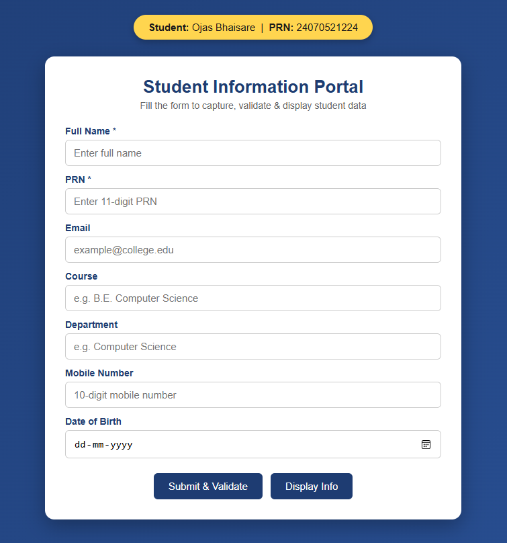

Casestudy – 1

Title: Design a departmental welcome webpage and implement JavaScript DOM manipulation to display student information dynamically.
Software/Tools Required: Visual Studio Code (or any text editor), Web Browser (Google Chrome, Microsoft Edge, Firefox, etc.)
Code:
<!DOCTYPE html>
<html lang="en">
<head>
<meta charset="UTF-8">
<meta name="viewport" content="width=device-width, initial-scale=1.0">
<title>CSE Department - SIT Nagpur</title>
<link rel="stylesheet" href="style.css">
</head>
<body>

<header class="header">
<img src="logo.png.png" alt="SIT Logo" class="college-logo">
<div class="header-text">
<h1>Symbiosis Institute of Technology, Nagpur</h1>
<h2>Department of Computer Science & Engineering</h2>
</div>
</header>

<div class="container">
<div class="card">
<h3>Welcome to CSE Department</h3>
<p>Empowering the 2024-28 batch with modern web development skills and hands-on JavaScript programming.</p>

<button onclick="openStudentPage()" class="btn">View Student Information</button>
</div>
</div>

<script src="script.js"></script>

</body>
</html>

// External JS Program for SIT Nagpur

// 1. Display Alert Box when the page loads
window.onload = function() {
alert("Welcome to SIT Nagpur");

// 2. Using console.log() as per syllabus requirement
console.log("Welcome to Symbiosis Institute of Technology, Nagpur!");
console.log("Department: Computer Science & Engineering");
console.log("Developer: Ojas Bhaisare (PRN: 24070521224)");
};

// 3. Function to link and navigate to the Student Information page
function openStudentPage() {
console.log("Navigating to Student Info Page...");
// This JavaScript command changes the page
window.location.href = "student.html";
}

// Function to go back to Department Page
function goBackToDept() {
window.location.href = "department.html";
}

<!DOCTYPE html>
<html lang="en">
<head>
<meta charset="UTF-8">
<meta name="viewport" content="width=device-width, initial-scale=1.0">
<title>Student Profile - SIT Nagpur</title>
<link rel="stylesheet" href="style.css">
</head>
<body>

<header class="header">
<img src="logo.png.png" alt="SIT Logo" class="college-logo">
<div class="header-text">
<h1>Symbiosis Institute of Technology, Nagpur</h1>
<h2>Student Information Portal</h2>
</div>
</header>

<div class="container">
<div class="card student-card">
<h3>Student Profile</h3>
<div class="info-row">
<span class="label">Name:</span>
<span class="value">Ojas Bhaisare</span>
</div>
<div class="info-row">
<span class="label">PRN:</span>
<span class="value">24070521224</span>
</div>
<div class="info-row">
<span class="label">Semester:</span>
<span class="value">V</span>
</div>
<div class="info-row">
<span class="label">Course:</span>
<span class="value">Computer Science & Engineering</span>
</div>

<button onclick="goBackToDept()" class="btn btn-secondary" style="margin-top: 20px;">Back to Department</button>
</div>
</div>

<script src="script.js"></script>

</body>
</html>

/* SIT Nagpur Premium Aesthetic Theme */
@import url('https://fonts.googleapis.com/css2?family=Plus+Jakarta+Sans:wght@400;500;700&display=swap');

body {
font-family: 'Plus Jakarta Sans', 'Segoe UI', sans-serif;
margin: 0;
padding: 0;
background-color: #faf9f6; /* Soft aesthetic neutral beige */
color: #2c3e50;
}

/* Glassmorphism Header */
.header {
background: rgba(255, 255, 255, 0.85);
-webkit-backdrop-filter: blur(12px);
backdrop-filter: blur(12px);
padding: 15px 40px;
display: flex;
align-items: center;
border-bottom: 3px solid #b71a22; /* SIT Red */
box-shadow: 0 4px 30px rgba(0,0,0,0.03);
position: sticky;
top: 0;
z-index: 100;
}

.college-logo {
height: 75px;
margin-right: 25px;
transition: transform 0.3s ease;
}

.college-logo:hover {
transform: scale(1.05);
}

.header-text h1 {
margin: 0;
font-size: 1.4em;
color: #b71a22;
letter-spacing: 0.5px;
}

.header-text h2 {
margin: 4px 0 0 0;
font-size: 1.05em;
color: #7f8c8d;
font-weight: 500;
}

/* Main Content Area */
.container {
padding: 60px 20px;
display: flex;
justify-content: center;
animation: fadeIn 0.8s ease-out;
}

/* Premium Card Design with Soft Shadows */
.card {
background-color: #ffffff;
padding: 40px;
border-radius: 16px;
box-shadow: 0 10px 40px rgba(0,0,0,0.06);
max-width: 550px;
width: 100%;
border-top: 5px solid #b71a22;
text-align: center;
transition: transform 0.3s ease, box-shadow 0.3s ease;
}

.card:hover {
transform: translateY(-5px);
box-shadow: 0 15px 50px rgba(0,0,0,0.1);
}

.card h3 {
color: #2c3e50;
margin-top: 0;
font-size: 1.6em;
border-bottom: 2px solid #f4f1ea;
padding-bottom: 15px;
}

.card p {
line-height: 1.8;
color: #555;
margin-bottom: 35px;
font-size: 1.05em;
}

/* Modern Hover Buttons */
.btn {
display: inline-block;
background: linear-gradient(135deg, #b71a22, #8a1319);
color: white;
text-decoration: none;
border: none;
padding: 14px 30px;
border-radius: 30px; /* Pill shape for aesthetic look */
font-size: 1em;
font-weight: 600;
letter-spacing: 0.5px;
cursor: pointer;
box-shadow: 0 4px 15px rgba(183, 26, 34, 0.3);
transition: all 0.3s ease;
}

.btn:hover {
background: linear-gradient(135deg, #a0151c, #6b0f13);
box-shadow: 0 6px 20px rgba(183, 26, 34, 0.4);
transform: translateY(-2px);
}

.btn-secondary {
background: linear-gradient(135deg, #7f8c8d, #636e72);
box-shadow: 0 4px 15px rgba(127, 140, 141, 0.3);
}

.btn-secondary:hover {
background: linear-gradient(135deg, #636e72, #4d5659);
box-shadow: 0 6px 20px rgba(127, 140, 141, 0.4);
}

/* Student Profile Detail Rows */
.student-card {
text-align: left;
}

.info-row {
display: flex;
padding: 15px 10px;
border-bottom: 1px solid #f4f1ea;
transition: background-color 0.2s ease;
border-radius: 8px;
}

.info-row:hover {
background-color: #faf9f6;
}

.info-row .label {
font-weight: 700;
width: 130px;
color: #b71a22;
}

.info-row .value {
color: #34495e;
font-weight: 500;
}

/* Smooth Page Load Animation */
@keyframes fadeIn {
from {
opacity: 0;
transform: translateY(20px);
}
to {
opacity: 1;
transform: translateY(0);
}
}

Output:
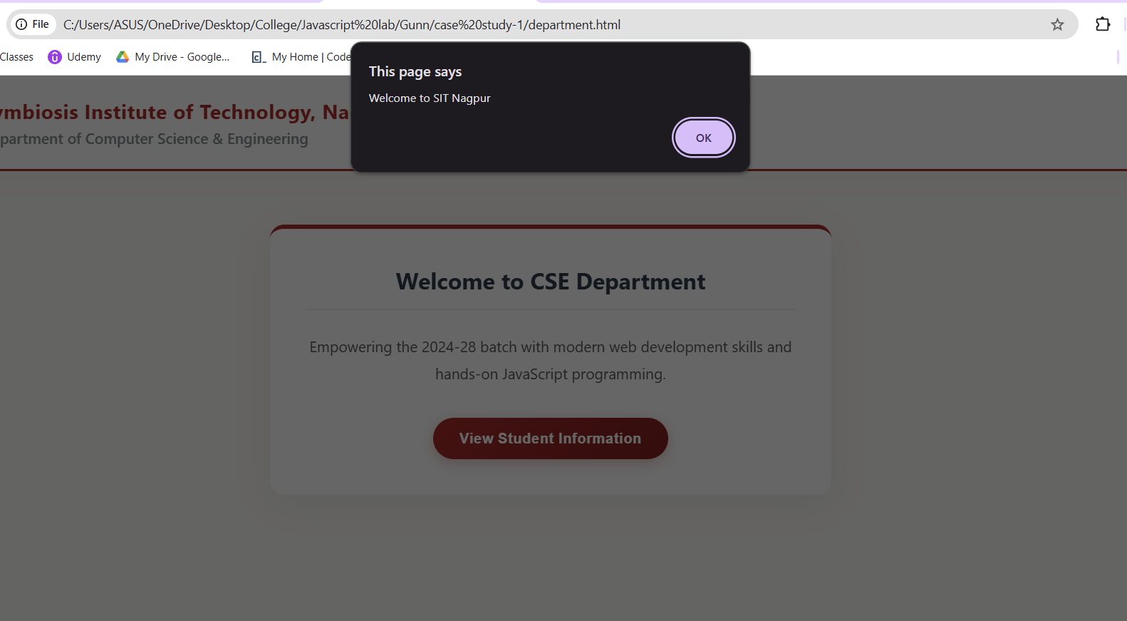
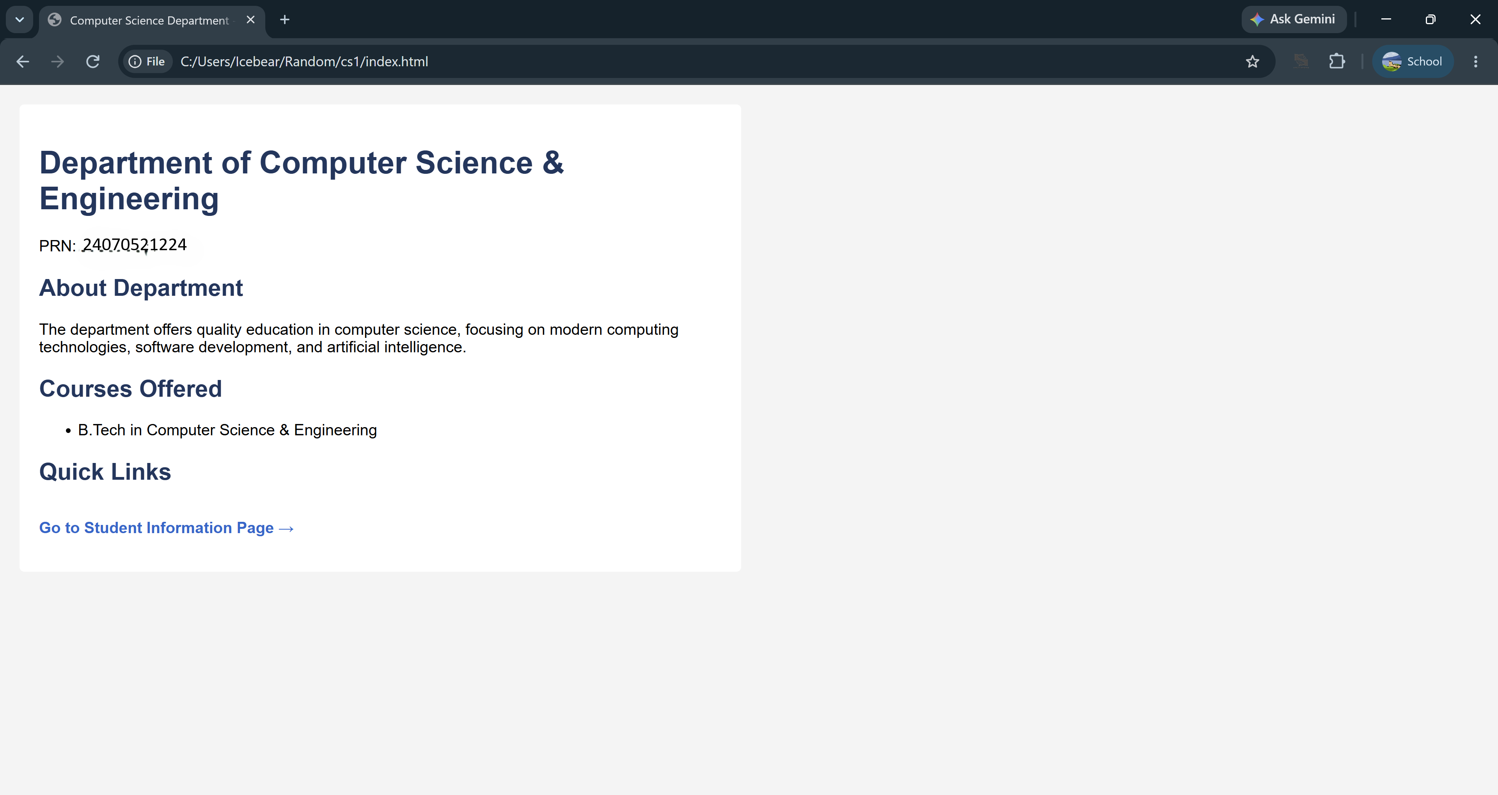

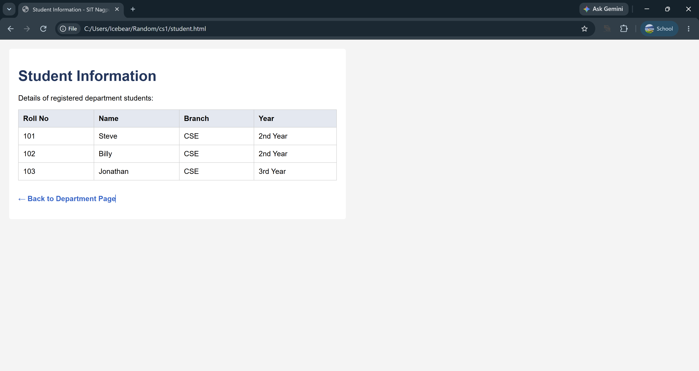
Result/Conclusion: The case study was successfully completed. A professional, responsive departmental welcome page was designed using HTML and CSS, matching the institutional theme. The core functionality of JavaScript DOM manipulation was successfully implemented, allowing the webpage to dynamically render student information upon user interaction via event listeners. This demonstrated a clear separation of concerns between structure (HTML), presentation (CSS), and behavior (JavaScript).

Experiment No.2
Title: Use var, let, const, and demonstrate basic features like template literals and destructuring; build a billing calculator with user input.

Software/Tools Required
- Any text/code editor (e.g., VS Code)
- Web browser (e.g., Chrome, Edge, Firefox) to render and view the HTML page
- Basic knowledge of HTML5 and CSS3

Theory:
JavaScript is a popular scripting language used to create interactive and dynamic web pages. It allows developers to perform calculations, handle user input, and update web content without reloading the page.
In this practical, modern JavaScript features are used to build a simple Billing Calculator that accepts user input and calculates the final bill after applying discount and GST.
The main concepts used are:
- var – Used to declare variables and can be redeclared and updated.
- let – Block-scoped variable that can be updated but not redeclared in the same scope.
- const – Block-scoped variable used for fixed values such as the GST rate.
- Template Literals – Used to display dynamic text by embedding variables using ${}.
- Destructuring – Used to extract values from arrays or objects in a simple and readable way.
The Billing Calculator takes inputs such as product name, quantity, price, discount, and GST. It performs the required calculations and displays the final payable amount in a clear format. This practical helps in understanding modern JavaScript syntax, improves coding efficiency, and demonstrates the real-world use of JavaScript in web development.

Output
On opening the Billing Calculator in a browser, the page displays input fields for the product name, quantity, price, discount, and GST (18%). After the user enters the required details and clicks the Calculate Bill button, the application computes the subtotal, applies the discount, adds the GST amount, and displays the final payable bill. The output is presented in a clear and formatted manner using JavaScript template literals.

Result / Conclusion
The Billing Calculator was successfully developed using modern JavaScript features such as var, let, const, template literals, and destructuring. It correctly accepts user input, calculates the bill by applying discount and 18% GST, and displays the final payable amount. This practical demonstrates the effective use of JavaScript for performing calculations and creating interactive web applications.

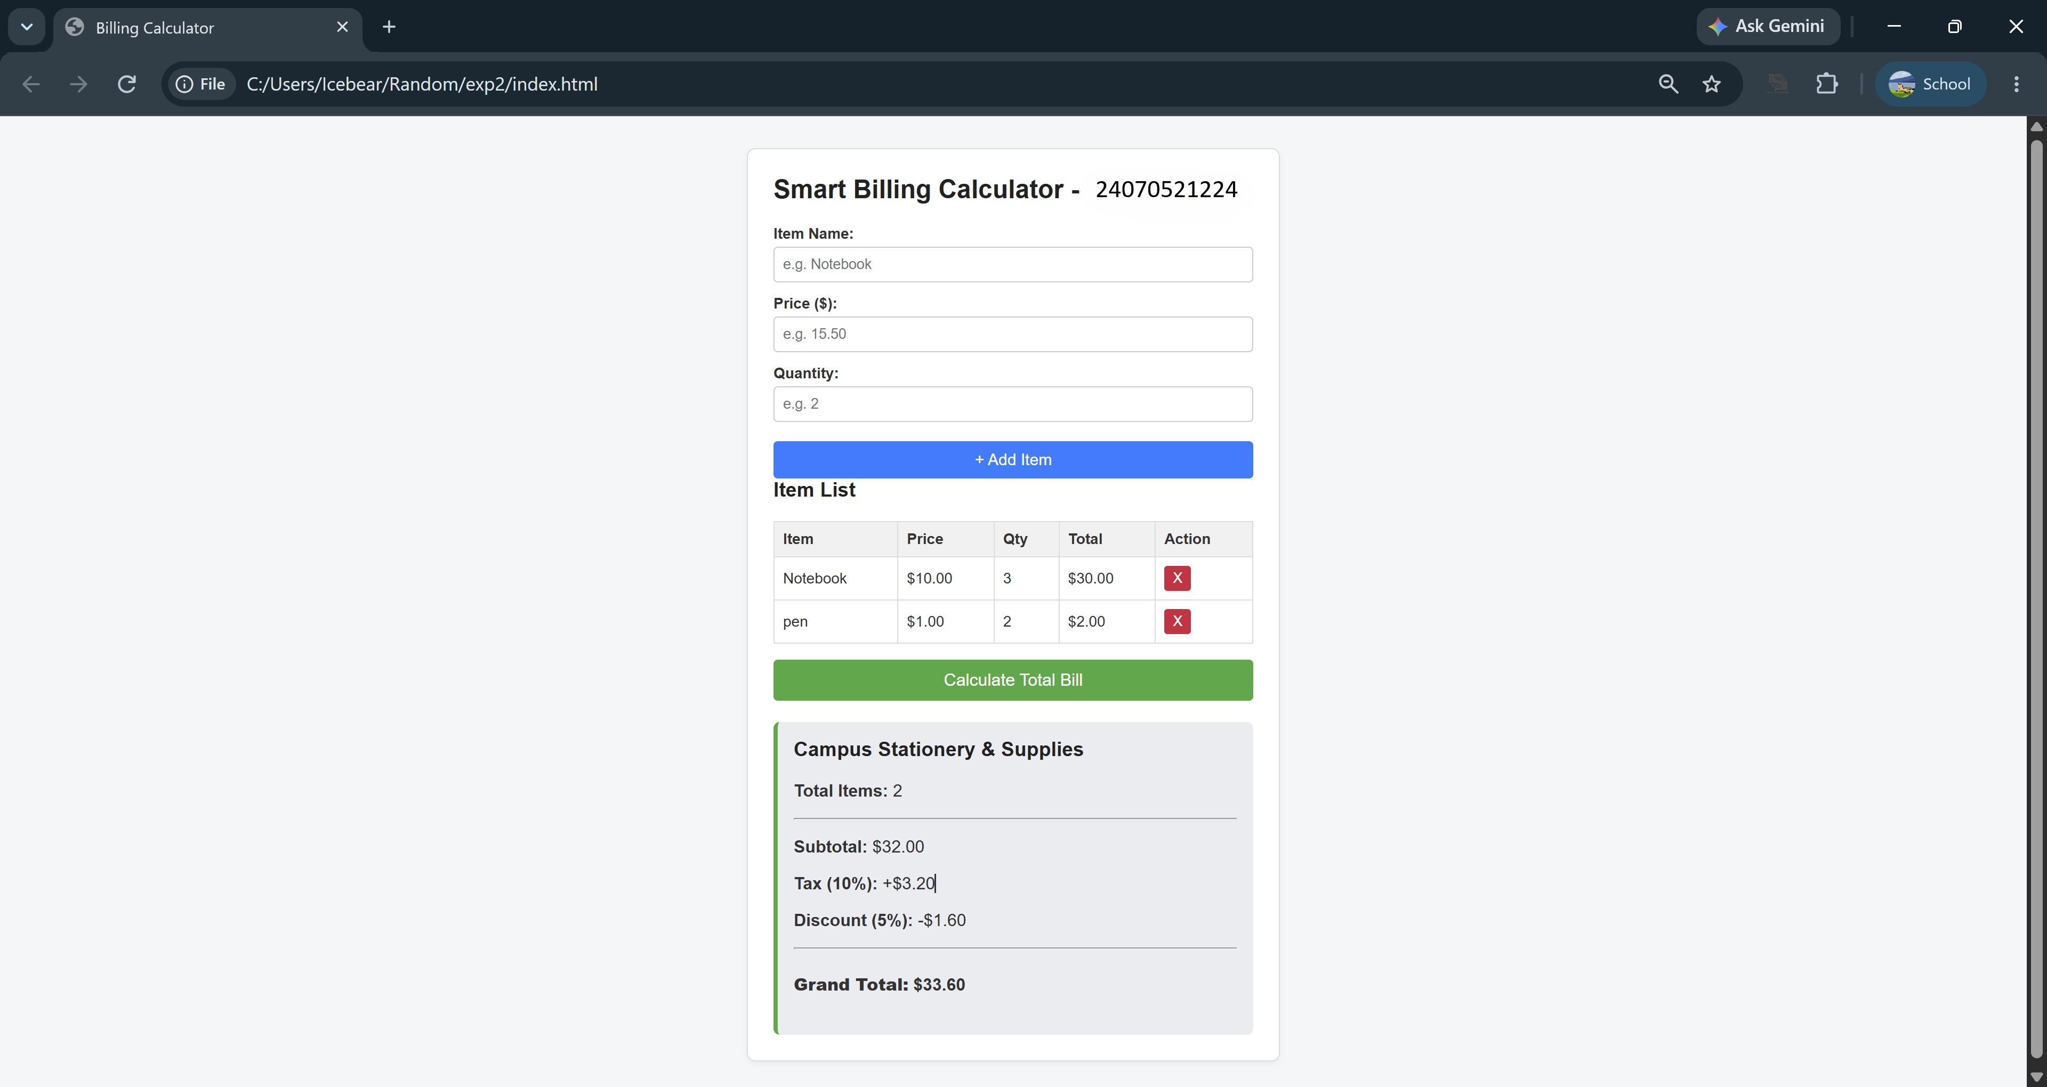

Casestudy – 2
Title: Build a dynamic Retail Billing Calculator using JavaScript DOM manipulation and diverse form controls. Software/Tools Required: Visual Studio Code, Web Browser.
Code :
<!DOCTYPE html>
<html lang="en">
<head>
<meta charset="UTF-8">
<meta name="viewport" content="width=device-width, initial-scale=1.0">
<title>Retail Billing System</title>
<style>
@import url('https://fonts.googleapis.com/css2?family=Plus+Jakarta+Sans:wght@400;500;600;700&display=swap');

/* LILAC DREAM AESTHETIC */
body {
font-family: 'Plus Jakarta Sans', sans-serif;
background-color: #f6f4fa; /* Soft Lavender Background */
color: #322e40;
margin: 0;
padding: 40px 20px;
display: flex;
justify-content: center;
}

.billing-container {
width: 100%;
max-width: 650px;
background: #ffffff;
padding: 35px 40px;
border-radius: 20px;
box-shadow: 0 15px 35px rgba(109, 89, 150, 0.08);
border-top: 6px solid #8b5cf6; /* Vibrant Violet Accent */
}

h2 {
margin: 0 0 15px 0;
font-size: 1.2em;
color: #4c1d95; /* Deep Indigo */
border-bottom: 2px solid #ede9fe;
padding-bottom: 10px;
}

.section-group {
margin-bottom: 30px;
}

.input-row {
display: flex;
gap: 20px;
margin-bottom: 15px;
}

.field {
flex: 1;
}

label {
display: block;
font-size: 0.85em;
font-weight: 600;
color: #5b21b6;
margin-bottom: 8px;
}

input[type="text"], input[type="number"] {
width: 100%;
padding: 12px 14px;
border: 1.5px solid #ddd6fe;
border-radius: 8px;
font-size: 0.95em;
font-family: inherit;
box-sizing: border-box;
outline: none;
transition: all 0.2s;
background: #faf9ff;
}

input[type="text"]:focus, input[type="number"]:focus {
border-color: #8b5cf6;
box-shadow: 0 0 0 3px rgba(139, 92, 246, 0.15);
background: #ffffff;
}

/* Radio & Checkbox Styling */
.radio-group {
display: flex;
gap: 15px;
align-items: center;
font-size: 0.9em;
margin-bottom: 12px;
color: #4c1d95;
font-weight: 500;
}

input[type="radio"], input[type="checkbox"] {
accent-color: #8b5cf6;
transform: scale(1.1);
margin-right: 5px;
cursor: pointer;
}

/* Buttons */
.btn-group {
display: flex;
gap: 15px;
margin-top: 25px;
justify-content: center;
}

button {
padding: 14px 28px;
border: none;
border-radius: 8px;
font-weight: 600;
font-size: 0.95em;
cursor: pointer;
transition: all 0.2s;
}

.btn-primary {
background: #8b5cf6;
color: white;
box-shadow: 0 4px 12px rgba(139, 92, 246, 0.3);
}

.btn-primary:hover {
background: #7c3aed;
transform: translateY(-2px);
}

.btn-secondary {
background: #f1f5f9;
color: #475569;
}

.btn-secondary:hover {
background: #e2e8f0;
}

/* Bill Summary Box */
.summary-box {
background: #faf9ff;
border: 1px solid #ddd6fe;
border-radius: 12px;
padding: 25px;
margin-top: 30px;
display: none;
animation: fadeIn 0.4s ease;
}

@keyframes fadeIn {
from { opacity: 0; transform: translateY(-10px); }
to { opacity: 1; transform: translateY(0); }
}

.summary-box h3 {
margin: 0 0 20px 0;
font-size: 1.4em;
color: #1e1b4b;
}

.summary-row {
display: flex;
justify-content: space-between;
margin-bottom: 12px;
font-size: 0.95em;
color: #4b5563;
}

.summary-divider {
border-top: 1px solid #c4b5fd;
margin: 15px 0;
}

.total-row {
display: flex;
justify-content: space-between;
font-size: 1.15em;
font-weight: 700;
color: #4c1d95;
}
</style>
</head>
<body>

<div class="billing-container">

<!-- SECTION 1: Product Information -->
<div class="section-group">
<h2>Product Information</h2>
<div class="field" style="margin-bottom: 15px;">
<label>Product Name</label>
<input type="text" id="pName" placeholder="e.g., Rice">
</div>
<div class="input-row">
<div class="field">
<label>Quantity (in Kg)</label>
<input type="number" id="qty" placeholder="0" min="0">
</div>
<div class="field">
<label>Rate per Kg (₹)</label>
<input type="number" id="rate" placeholder="0" min="0">
</div>
</div>
</div>

<!-- SECTION 2: Charges & Discounts -->
<div class="section-group">
<h2>Charges & Discounts</h2>
<div class="input-row">
<div class="field">
<label>Discount (%)</label>
<input type="number" id="discount" placeholder="0" min="0">
</div>
<div class="field">
<label>GST (%)</label>
<input type="number" id="gst" placeholder="0" min="0">
</div>
</div>
<div class="field">
<label>Packing Charges (₹)</label>
<input type="number" id="packing" placeholder="0" min="0">
</div>
</div>

<!-- SECTION 3: Payment & Membership -->
<div class="section-group">
<h2>Payment & Membership</h2>
<label style="margin-bottom: 10px;">Payment Mode</label>
<div class="radio-group">
<label><input type="radio" name="payMode" value="Cash"> Cash</label>
<label><input type="radio" name="payMode" value="Card"> Card</label>
<label><input type="radio" name="payMode" value="UPI" checked> UPI</label>
</div>

<div class="radio-group" style="margin-top: 15px;">
<label><input type="checkbox" id="membership" checked> Membership (Yes/No)</label>
</div>
</div>

<!-- Bill Summary Output -->
<div id="summaryBox" class="summary-box">
<h3>Bill Summary</h3>
<div class="summary-row">
<span>Product Cost (Qty × Rate):</span>
<span id="outCost">₹ 0.00</span>
</div>
<div class="summary-row">
<span id="outDiscountLabel">Discount (0.00%):</span>
<span id="outDiscountAmt">- ₹ 0.00</span>
</div>
<div class="summary-row" style="font-weight: 600; color: #322e40;">
<span>Subtotal:</span>
<span id="outSubtotal">₹ 0.00</span>
</div>
<div class="summary-row">
<span id="outGstLabel">GST (0.00%):</span>
<span id="outGstAmt">+ ₹ 0.00</span>
</div>
<div class="summary-row">
<span>Packing Charges:</span>
<span id="outPacking">+ ₹ 0.00</span>
</div>

<div class="summary-divider"></div>

<div class="total-row">
<span>Total Bill Amount:</span>
<span id="outTotal">₹ 0.00</span>
</div>
</div>

<!-- Action Buttons -->
<div class="btn-group">
<button class="btn-primary" onclick="calculateBill()">Calculate Bill</button>
<button class="btn-secondary" onclick="clearForm()">Clear Form</button>
</div>

</div>

<script>
function calculateBill() {
// 1. Fetch Values
const qty = Number(document.getElementById('qty').value) || 0;
const rate = Number(document.getElementById('rate').value) || 0;
const discPerc = Number(document.getElementById('discount').value) || 0;
const gstPerc = Number(document.getElementById('gst').value) || 0;
const packing = Number(document.getElementById('packing').value) || 0;

// 2. Mathematical Calculations (Exactly matching screenshot logic)
const productCost = qty * rate;
const discountAmt = productCost * (discPerc / 100);
const subtotal = productCost - discountAmt;
const gstAmt = subtotal * (gstPerc / 100);
const totalBill = subtotal + gstAmt + packing;

// 3. Update DOM Output
document.getElementById('outCost').innerText = `₹ ${productCost.toFixed(2)}`;

document.getElementById('outDiscountLabel').innerText = `Discount (${discPerc.toFixed(2)}%):`;
document.getElementById('outDiscountAmt').innerText = `- ₹ ${discountAmt.toFixed(2)}`;

document.getElementById('outSubtotal').innerText = `₹ ${subtotal.toFixed(2)}`;

document.getElementById('outGstLabel').innerText = `GST (${gstPerc.toFixed(2)}%):`;
document.getElementById('outGstAmt').innerText = `+ ₹ ${gstAmt.toFixed(2)}`;

document.getElementById('outPacking').innerText = `+ ₹ ${packing.toFixed(2)}`;

document.getElementById('outTotal').innerText = `₹ ${totalBill.toFixed(2)}`;

// Make the summary box visible
document.getElementById('summaryBox').style.display = 'block';
}

function clearForm() {
// Clear all text and number inputs
document.getElementById('pName').value = '';
document.getElementById('qty').value = '';
document.getElementById('rate').value = '';
document.getElementById('discount').value = '';
document.getElementById('gst').value = '';
document.getElementById('packing').value = '';

// Reset radios and checkboxes to default state
document.querySelector('input[name="payMode"][value="UPI"]').checked = true;
document.getElementById('membership').checked = true;

// Hide summary box
document.getElementById('summaryBox').style.display = 'none';
}
</script>
</body>
</html>

Output:
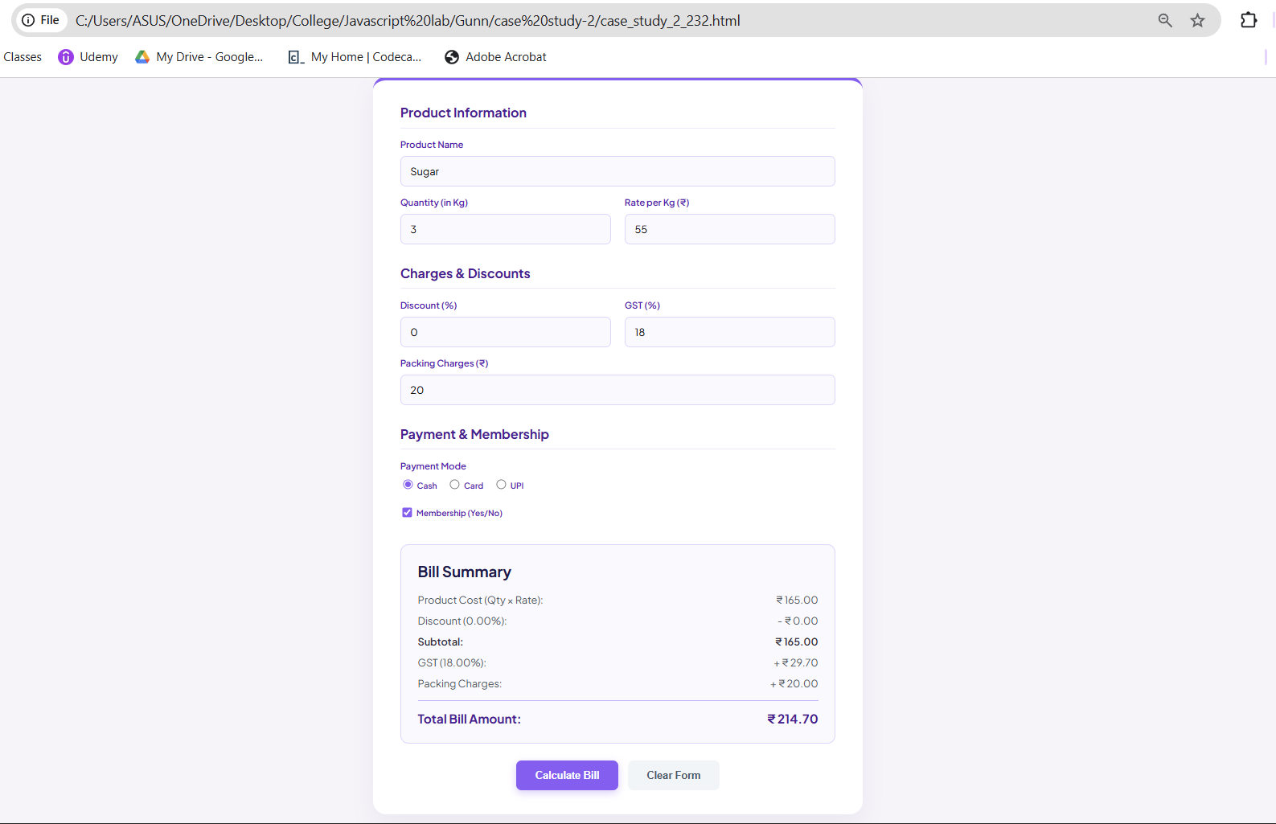
Result/Conclusion: The case study was successfully completed. A comprehensive retail billing calculator was developed using HTML, CSS, and JavaScript. The program successfully retrieved data from various input types (text, number, radio, checkbox), executed sequential financial arithmetic (including discount and GST percentages), and dynamically injected the formatted itemized bill into the webpage's DOM.

Experiment No.3
Title: Implement control structures and form validation; create a grading system based on user-entered marks.

Software/Tools Required
- Any text/code editor (e.g., VS Code)
- Web browser (e.g., Chrome, Edge, Firefox) to render and view the HTML page
- Basic knowledge of HTML5 and CSS3

Theory:
JavaScript is a client-side scripting language used to create dynamic and interactive web pages. It provides control structures such as if, if-else, else-if, switch, and loops to control the flow of a program based on conditions. Form validation ensures that the user enters valid data before processing it, reducing errors and improving reliability. In this practical, the user enters marks between 0 and 100, and the program first validates the input. If the entered marks are valid, the program uses if-else statements to assign grades according to the following criteria: 90–100 = A+, 80–89 = A, 70–79 = B, 60–69 = C, 50–59 = D, and below 50 = Fail.

Output:
- Input: Marks = 95 → Output: Grade: A+
- Input: Marks = 76 → Output: Grade: B
- Input: Marks = 48 → Output: Grade: Fail
- Input: Marks = 120 → Output: Marks should be between 0 and 100.
- Input: Empty field → Output: Please enter marks.

Result/Conclusion:
The grading system was successfully implemented using JavaScript control structures and form validation. The program accurately validates the user-entered marks, prevents invalid inputs, and assigns the correct grade based on predefined conditions. This practical demonstrates the effective use of conditional statements and input validation to create a simple, reliable, and user-friendly web application.

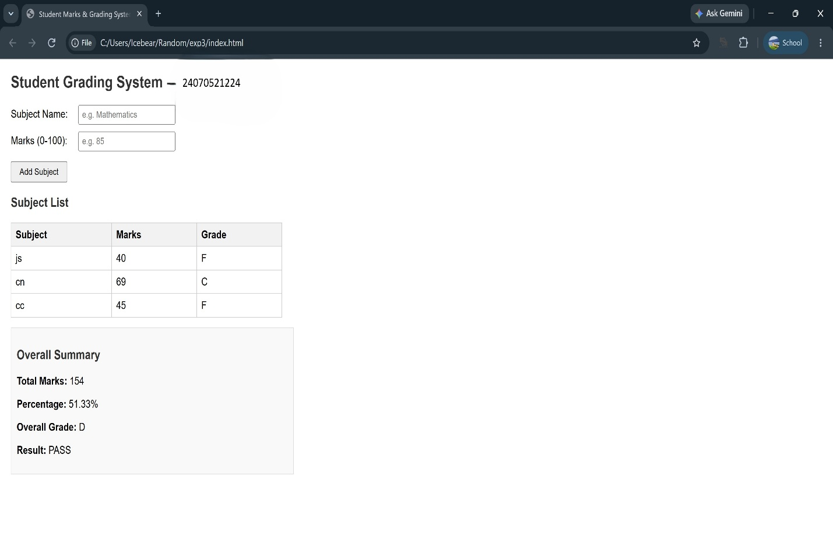
Casestudy – 3
Title: Write a JavaScript program that accepts student marks and displays the scholarship category using conditional control structures.
Software/Tools Required: Visual Studio Code (or any text editor), Web Browser (Google Chrome, Microsoft Edge, Firefox, etc.)
Code:
<!DOCTYPE html>
<html lang="en">
<head>
<meta charset="UTF-8">
<meta name="viewport" content="width=device-width, initial-scale=1.0">
<title>Scholarship Eligibility Checker</title>
<style>
@import url('https://fonts.googleapis.com/css2?family=Inter:wght@400;500;600;700&display=swap');

/* NORDIC ICE & SAGE GREEN AESTHETIC */
body {
font-family: 'Inter', sans-serif;
background-color: #f4f7f6; /* Soft Ice/Grey-Green Background */
display: flex;
justify-content: center;
align-items: center;
height: 100vh;
margin: 0;
color: #2c3e50;
}

.card {
background-color: #ffffff;
width: 100%;
max-width: 420px;
padding: 40px;
border-radius: 16px;
box-shadow: 0 10px 30px rgba(0, 0, 0, 0.04), 0 1px 3px rgba(0,0,0,0.02);
text-align: center;
border-top: 5px solid #789c78; /* Sage Green Accent */
}

h2 {
margin-top: 0;
margin-bottom: 25px;
font-size: 1.6em;
color: #333;
font-weight: 700;
line-height: 1.3;
}

.input-group {
text-align: left;
margin-bottom: 20px;
}

label {
display: block;
font-size: 0.9em;
font-weight: 600;
color: #555;
margin-bottom: 8px;
}

input[type="number"] {
width: 100%;
padding: 12px 15px;
font-size: 1em;
font-family: inherit;
border: 1.5px solid #d1d9d4;
border-radius: 8px;
box-sizing: border-box;
outline: none;
transition: all 0.2s ease;
background-color: #fcfdfc;
}

input[type="number"]:focus {
border-color: #789c78;
box-shadow: 0 0 0 3px rgba(120, 156, 120, 0.15);
}

.btn-check {
width: 100%;
padding: 14px;
background-color: #789c78; /* Classy Sage Green */
color: #ffffff;
border: none;
border-radius: 8px;
font-size: 1em;
font-weight: 600;
cursor: pointer;
transition: background-color 0.2s ease, transform 0.1s ease;
}

.btn-check:hover {
background-color: #648564;
transform: translateY(-1px);
}

.result-box {
margin-top: 20px;
padding: 15px;
background-color: #eef2ef; /* Soft grey matching screenshot */
border: 1px solid #dcdcdc;
border-radius: 8px;
font-size: 0.95em;
font-weight: 500;
color: #333;
display: none; /* Hidden by default */
animation: fadeIn 0.3s ease-in-out;
}

@keyframes fadeIn {
from { opacity: 0; transform: translateY(-5px); }
to { opacity: 1; transform: translateY(0); }
}
</style>
</head>
<body>

<div class="card">
<h2>Scholarship Eligibility<br>Checker</h2>

<div class="input-group">
<label for="marks">Enter Student Marks (0-100):</label>
<input type="number" id="marks" min="0" max="100" placeholder="e.g. 95">
</div>

<button class="btn-check" onclick="checkEligibility()">Check Eligibility</button>

<div id="output" class="result-box"></div>
</div>

<script>
function checkEligibility() {
const marksInput = document.getElementById('marks').value;
const outputBox = document.getElementById('output');

// Validation: Check if input is empty or out of range
if (marksInput === '' || marksInput < 0 || marksInput > 100) {
outputBox.innerHTML = "<span style='color: #c0392b;'>⚠️ Please enter valid marks between 0 and 100.</span>";
outputBox.style.display = "block";
outputBox.style.backgroundColor = "#fdf0f0";
return;
}

const marks = Number(marksInput);
let scholarship = "";

// If-Else Ladder for Scholarship Categories
if (marks >= 90) {
scholarship = "Platinum Scholarship";
} else if (marks >= 75) {
scholarship = "Gold Scholarship";
} else if (marks >= 60) {
scholarship = "Silver Scholarship";
} else if (marks >= 40) {
scholarship = "Bronze Scholarship";
} else {
scholarship = "No Scholarship";
}

// Displaying exact format requested in screenshot
outputBox.innerHTML = `<strong>Marks:</strong> ${marks} &nbsp; <strong>Scholarship:</strong> ${scholarship}`;

// Resetting background color in case of previous error
outputBox.style.backgroundColor = "#eef2ef";
outputBox.style.display = "block";
}
</script>
</body>
</html>

Output:
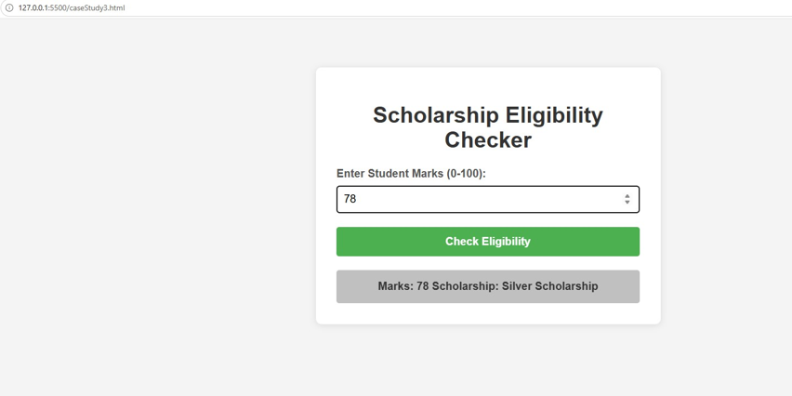
Result/Conclusion: The case study was successfully completed. A dynamic JavaScript program was developed to accept numerical marks, validate the input range, and apply a sequential if-else logic ladder to determine the correct scholarship tier (e.g., Platinum, Gold, Silver, Bronze). The core logic was successfully integrated with the front-end, allowing the result to be dynamically displayed on the web interface using DOM manipulation techniques without requiring a page reload.

Experiment No.4
Title: Use function types, scope, and closures; apply try-catch; build a palindrome checker.

Software/Tools Required
- Any text/code editor (e.g., VS Code)
- Web browser (e.g., Chrome, Edge, Firefox) to render and view the HTML page
- Basic knowledge of HTML5 and CSS3

Theory:
JavaScript functions are used to perform specific tasks in a program. Functions can be of different types such as named functions, anonymous functions, and arrow functions. Scope defines where a variable can be accessed in a program, while a closure allows a function to remember variables from its outer function even after it has finished executing. The try-catch statement is used to handle errors and prevent the program from crashing. In this practical, the user enters a word or sentence, and the program checks whether it is a palindrome by comparing the original text with its reverse. If the input is invalid or empty, an appropriate error message is displayed.

Code:-
<!DOCTYPE html>
<html lang="en">
<head>
<meta charset="UTF-8">
<title>Palindrome Checker</title>
<style>
body{font-family:Arial,sans-serif;background:#f4f4f8;margin:0;display:flex;justify-content:center;align-items:center;height:100vh}
.card{background:#fff;padding:26px 36px;border-radius:8px;text-align:center;box-shadow:0 1px 8px rgba(0,0,0,.15);width:360px}
h2{margin:0 0 4px}
.who{font-size:13px;color:#555;margin-bottom:14px}
input{width:100%;box-sizing:border-box;padding:8px;border:1px solid #bbb;border-radius:4px}
button{background:#3b6cf6;color:#fff;border:0;padding:8px 20px;border-radius:4px;margin-top:12px;cursor:pointer}
#result{margin-top:16px;font-weight:bold;min-height:20px}
.ok{color:#2e7d32}.no{color:#b26a00}.err{color:#c62828}
</style>
</head>
<body>
<div class="card">
<h2>Palindrome Checker - 24070521224</h2>
<div class="who">Ojas Bhaisare</div>
<input id="text" placeholder="Enter word or phrase">
<button id="check">Check</button>
<div id="result"></div>
</div>
<script>
// Closure: count remembers its value between calls (private variable)
function makeCounter() {
let count = 0;
return function () { count += 1; return count; };
}
const nextCheck = makeCounter();
// Named function: cleans text so spaces, case and punctuation are ignored
function normalize(str) {
return str.toLowerCase().replace(/[^a-z0-9]/g, "");
}
// Arrow function: compares text with its reverse
const isPalindrome = (str) => {
const clean = normalize(str);
if (clean.length === 0) throw new Error("Please enter valid text.");
return clean === clean.split("").reverse().join("");
};
// Anonymous function used as the click handler
document.getElementById("check").addEventListener("click", function () {
const input = document.getElementById("text").value;
const out = document.getElementById("result");
try {
const yes = isPalindrome(input);
out.className = yes ? "ok" : "no";
out.textContent = '"' + input.trim() + '" is ' + (yes ? "a palindrome!" : "not a palindrome.") + " (Check #" + nextCheck() + ")";
} catch (e) {
out.className = "err";
out.textContent = e.message;
}
});
</script>
</body>
</html>

Output:
- Input: madam → Output: Palindrome
- Input: racecar → Output: Palindrome
- Input: hello → Output: Not a Palindrome
- Input: A man a plan a canal Panama → Output: Palindrome
- Input: Empty Field → Output: Please enter valid text.

Result/Conclusion:
The palindrome checker was successfully implemented using JavaScript functions, scope, closures, and try-catch. The program correctly checks whether the entered text is a palindrome and handles invalid input without stopping the execution, making it simple, reliable, and user-friendly.
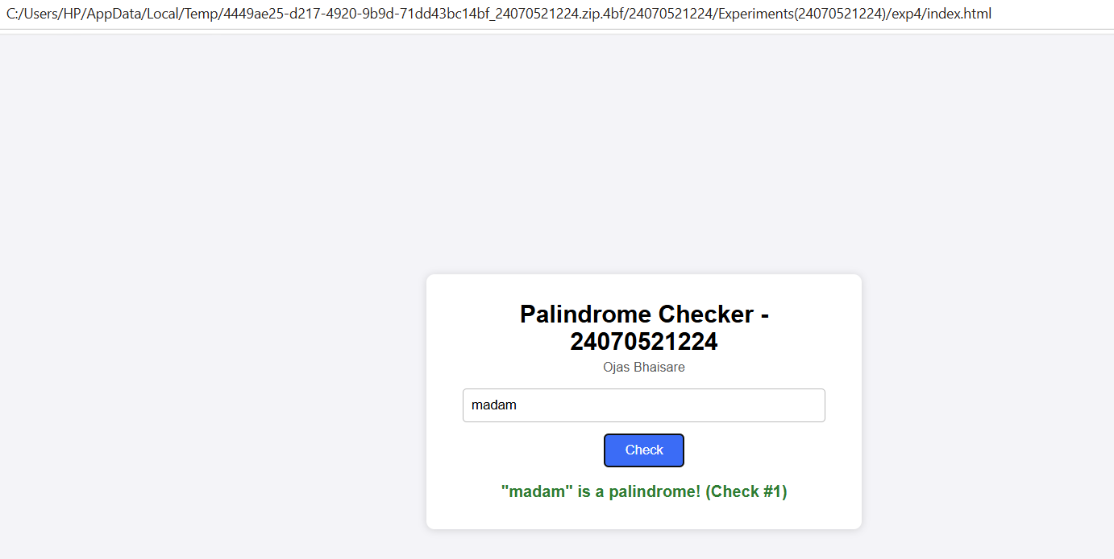
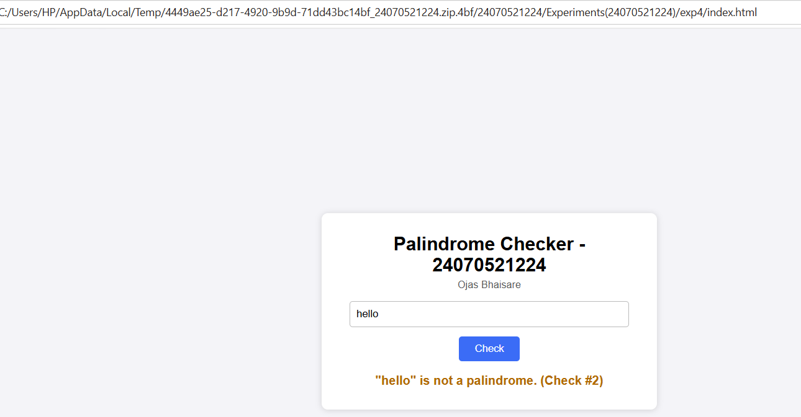

Casestudy – 4
Case Study 4
Title: Real-Time Case Study: ATM Card PIN Verification Using JavaScript Functions (Palindrome Checker).
Software/Tools Required: Visual Studio Code (or any text editor), Web Browser (Google Chrome, Microsoft Edge, Firefox, etc.)
Code:
<!DOCTYPE html>
<html lang="en">
<head>
<meta charset="UTF-8">
<meta name="viewport" content="width=device-width, initial-scale=1.0">
<title>Secure Banking | PIN Verification</title>
<style>
@import url('https://fonts.googleapis.com/css2?family=Roboto:wght@400;500;700&family=Courier+Prime:wght@700&display=swap');

/* CORPORATE BANKING THEME */
body {
font-family: 'Roboto', sans-serif;
background-color: #f0f2f5; /* Standard corporate light grey */
color: #333333;
margin: 0;
display: flex;
flex-direction: column;
align-items: center;
min-height: 100vh;
}

/* Fake Bank Header */
.bank-navbar {
width: 100%;
background-color: #003366; /* Deep Navy Blue */
color: white;
padding: 15px 20px;
box-shadow: 0 2px 4px rgba(0,0,0,0.1);
display: flex;
justify-content: space-between;
align-items: center;
box-sizing: border-box;
}

.bank-navbar h2 {
margin: 0;
font-size: 1.4em;
letter-spacing: 1px;
display: flex;
align-items: center;
gap: 10px;
}

.container {
width: 100%;
max-width: 450px;
background: #ffffff;
margin-top: 50px;
border: 1px solid #d1d5db;
border-radius: 4px;
box-shadow: 0 4px 6px rgba(0,0,0,0.05);
overflow: hidden;
}

/* Form Header */
.form-header {
background-color: #f8f9fa;
border-bottom: 1px solid #e5e7eb;
padding: 20px;
text-align: center;
}

.form-header h3 {
margin: 0;
color: #003366;
font-size: 1.2em;
}

.form-header p {
margin: 5px 0 0 0;
color: #6b7280;
font-size: 0.85em;
}

/* Content Area */
.content {
padding: 30px 20px;
}

label {
display: block;
font-size: 0.85em;
font-weight: 700;
color: #374151;
margin-bottom: 8px;
}

/* PIN Input */
input[type="text"] {
width: 100%;
padding: 12px;
background: #ffffff;
border: 1px solid #9ca3af;
border-radius: 4px;
color: #111827;
font-size: 1.4em;
font-family: 'Courier Prime', monospace;
text-align: center;
letter-spacing: 5px;
box-sizing: border-box;
outline: none;
}

input[type="text"]:focus {
border-color: #0056b3;
box-shadow: 0 0 0 2px rgba(0, 86, 179, 0.2);
}

/* Corporate Button */
.btn-verify {
width: 100%;
background-color: #0056b3;
color: #ffffff;
border: none;
padding: 14px;
border-radius: 4px;
font-size: 1em;
font-weight: 700;
text-transform: uppercase;
cursor: pointer;
margin-top: 20px;
transition: background-color 0.2s;
}

.btn-verify:hover {
background-color: #004494;
}

/* System Alert Boxes */
.alert-box {
display: none;
margin-top: 20px;
padding: 15px;
border-radius: 4px;
border-left: 5px solid;
font-size: 0.9em;
line-height: 1.5;
}

.alert-success {
background-color: #f0fdf4;
border-color: #16a34a;
color: #166534;
}

.alert-info {
background-color: #eff6ff;
border-color: #2563eb;
color: #1e3a8a;
}

.alert-error {
background-color: #fef2f2;
border-color: #dc2626;
color: #991b1b;
}

/* Footer/Closure Stats */
.system-footer {
background-color: #f8f9fa;
border-top: 1px solid #e5e7eb;
padding: 12px 20px;
display: flex;
justify-content: space-between;
font-size: 0.8em;
color: #6b7280;
font-weight: 500;
}

.badge {
background: #e5e7eb;
padding: 2px 8px;
border-radius: 12px;
color: #374151;
font-weight: 700;
}
</style>
</head>
<body>

<!-- Corporate Navbar -->
<div class="bank-navbar">
<h2>🏦 Global Secure Bank</h2>
<span style="font-size: 0.85em;">Customer Portal</span>
</div>

<!-- Verification Interface -->
<div class="container">
<div class="form-header">
<h3>🔒 ATM PIN Authentication</h3>
<p>Please enter your 4-8 digit ATM PIN securely.</p>
</div>

<div class="content">
<label>ENTER PIN</label>
<input type="text" id="pinInput" placeholder="****" maxlength="8" autocomplete="off" onkeypress="return event.charCode >= 48 && event.charCode <= 57">

<button class="btn-verify" onclick="verifyATM()">Submit & Verify</button>

<!-- Dynamic System Alerts -->
<div id="outputMessage" class="alert-box"></div>
</div>

<!-- Lexical Closure Tracking (System Data) -->
<div class="system-footer">
<span>Server Session Attempts:</span>
<span class="badge" id="attemptCount">0</span>
</div>
</div>

<script>
// ==========================================
// 1. SCOPE & CLOSURE (Simulating secure session tracking)
// ==========================================
const secureATMSession = () => {
let attempts = 0; // Local block scope, hidden from window object

return {
logAttempt: () => {
attempts++;
document.getElementById('attemptCount').innerText = attempts;
}
};
};
const atmSession = secureATMSession();

// ==========================================
// 2. FUNCTION EXPRESSION
// ==========================================
const reversePin = function(pinString) {
return pinString.split('').reverse().join('');
};

// ==========================================
// 3. ARROW FUNCTION
// ==========================================
const checkPalindrome = (original, reversed) => {
return original === reversed;
};

// ==========================================
// 4. FUNCTION DECLARATION & TRY-CATCH
// ==========================================
function verifyATM() {
const inputField = document.getElementById('pinInput');
const outputBox = document.getElementById('outputMessage');

// Reset state
outputBox.style.display = 'none';
outputBox.className = 'alert-box';

try {
const rawPin = inputField.value.trim();

// Form Validation
if (rawPin === "") {
throw new Error("PIN entry cannot be blank. Please enter your PIN.");
}

if (!/^[0-9]+$/.test(rawPin)) {
throw new Error("Security Error: PIN must contain numeric values only.");
}

// Log attempt via Closure securely
atmSession.logAttempt();

// Process Logic
const reversedString = reversePin(rawPin);
const isPal = checkPalindrome(rawPin, reversedString);

// Update UI based on Palindrome logic
if (isPal) {
outputBox.innerHTML = `<strong>System Alert: Palindrome Match</strong><br>Verification successful. Special security protocol activated.`;
outputBox.classList.add('alert-success');
} else {
outputBox.innerHTML = `<strong>System Alert: Standard PIN</strong><br>Authentication successful. Access granted to standard features.`;
outputBox.classList.add('alert-info');
}

outputBox.style.display = 'block';

} catch (error) {
// Catch errors and display properly formatted error alert
outputBox.innerHTML = `<strong>Transaction Failed:</strong><br>${error.message}`;
outputBox.classList.add('alert-error');
outputBox.style.display = 'block';
}
}
</script>
</body>
</html>

Output:
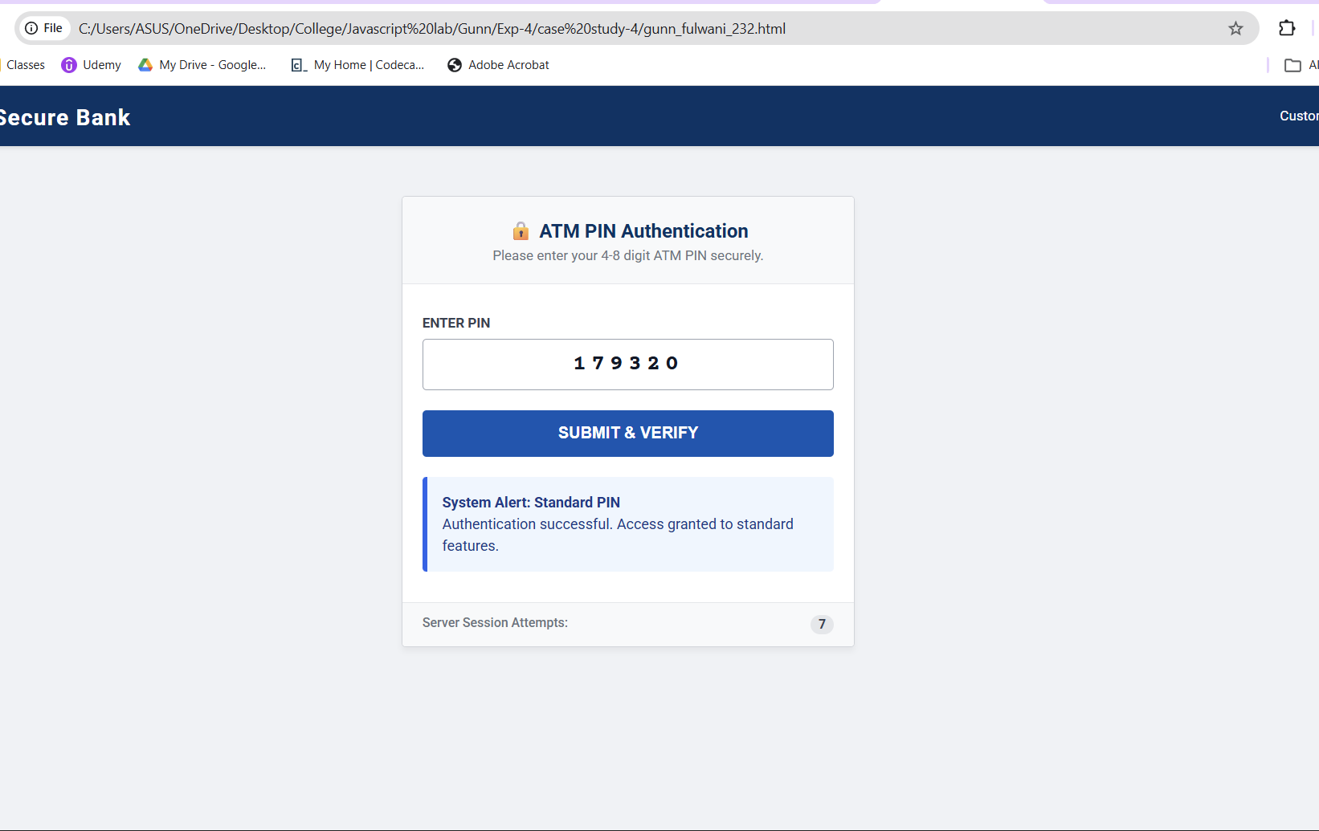

Result/Conclusion:
The case study was successfully completed. The ATM Card PIN Verification system was implemented using three distinct JavaScript function types: declarations, expressions, and arrow functions. Furthermore, a secure lexical closure was successfully integrated to track user attempts independently of the global scope. Form validation and robust error handling were achieved using a try...catch block, resulting in a secure, dynamic, and aesthetic web interface.

Experiment – 5

Aim:-
Apply array methods and object handling; create a cart total calculator with discount logic.

Software/Tools Required:-
- Visual Studio Code (or any text editor)
- Web Browser (Google Chrome/Microsoft Edge)
- HTML, CSS, and JavaScript

Code:-
<!DOCTYPE html>
<html>
<head>
<title>Interactive Shopping Cart</title>
<style>
body{
font-family: Arial, sans-serif;
background:#f4f4f4;
}
.container{
width:450px;
margin:40px auto;
background:white;
padding:20px;
border-radius:10px;
box-shadow:0 0 10px gray;
text-align:center;
}
select,input,button{
padding:8px;
margin:8px;
}
table{
width:100%;
border-collapse:collapse;
margin-top:20px;
}
table,th,td{
border:1px solid #999;
}
th,td{
padding:8px;
}
th{
background:#4CAF50;
color:white;
}
#result{
margin-top:20px;
font-size:18px;
font-weight:bold;
}
</style>
</head>
<body>

<div class="container">
<h2>Shopping Cart Calculator</h2>

<label>Item:</label>
<select id="item">
<option value="800">Laptop ($800)</option>
<option value="25">Mouse ($25)</option>
<option value="50">Keyboard ($50)</option>
<option value="100">Headphones ($100)</option>
<option value="300">Monitor ($300)</option>
</select>

<br>

<label>Quantity:</label>
<input type="number" id="qty" min="1" placeholder="Enter quantity">

<br>

<button onclick="addToCart()">Add to Cart</button>
<button onclick="calculateBill()">Calculate Bill</button>
<button onclick="clearCart()">Clear Cart</button>

<table>
<thead>
<tr>
<th>Item</th>
<th>Price</th>
<th>Qty</th>
<th>Total</th>
</tr>
</thead>
<tbody id="cartTable"></tbody>
</table>

<div id="result"></div>
</div>

<script>

const cart = [];

function addToCart(){

let select = document.getElementById("item");
let name = select.options[select.selectedIndex].text.split(" (")[0];
let price = Number(select.value);
let qty = Number(document.getElementById("qty").value);

if(qty <= 0 || isNaN(qty)){
alert("Please enter a valid quantity.");
return;
}

cart.push({
name:name,
price:price,
quantity:qty
});

displayCart();

document.getElementById("qty").value="";
}

function displayCart(){

let table = document.getElementById("cartTable");
table.innerHTML="";

cart.forEach(item=>{

table.innerHTML += `
<tr>
<td>${item.name}</td>
<td>$${item.price}</td>
<td>${item.quantity}</td>
<td>$${item.price*item.quantity}</td>
</tr>`;

});

}

function calculateBill(){

if(cart.length===0){
alert("Cart is empty!");
return;
}

let total = cart.reduce((sum,item)=>sum+(item.price*item.quantity),0);

let discount=0;

if(total>=1000)
discount=total*0.20;
else if(total>=500)
discount=total*0.10;
else if(total>=200)
discount=total*0.05;

let finalAmount=total-discount;

document.getElementById("result").innerHTML=
`
Total : $${total.toFixed(2)} <br>
Discount : $${discount.toFixed(2)} <br>
<span style="color:green;">Final Amount : $${finalAmount.toFixed(2)}</span>
`;

}

function clearCart(){

cart.length=0;
document.getElementById("cartTable").innerHTML="";
document.getElementById("result").innerHTML="";
}

</script>

</body>
</html>

Theory:-
A cart total calculator in JavaScript can be implemented using arrays, objects, and array methods to manage products and calculate the final payable amount. Each product can be represented as an object containing properties such as product name, price, and quantity. An array stores all the product objects in the shopping cart.

Array methods make the calculation simpler and more efficient:-

map() can be used to calculate the subtotal of each product by multiplying its price by its quantity.
reduce() can calculate the total cart value by adding all product subtotals.
filter() can be used to identify products or conditions that meet specific requirements, if needed.
Object handling allows individual product details to be accessed and modified using properties such as price, quantity, and name.
Conditional statements can implement discount logic. For example, a percentage discount can be applied when the cart total exceeds a specified amount.
The final amount is calculated by subtracting the discount from the original cart total.

A typical calculation is:

Subtotal = Σ (Product Price × Quantity)

If the subtotal satisfies the discount condition:

Discount = Subtotal × Discount Rate

Final Total = Subtotal − Discount

Output:-
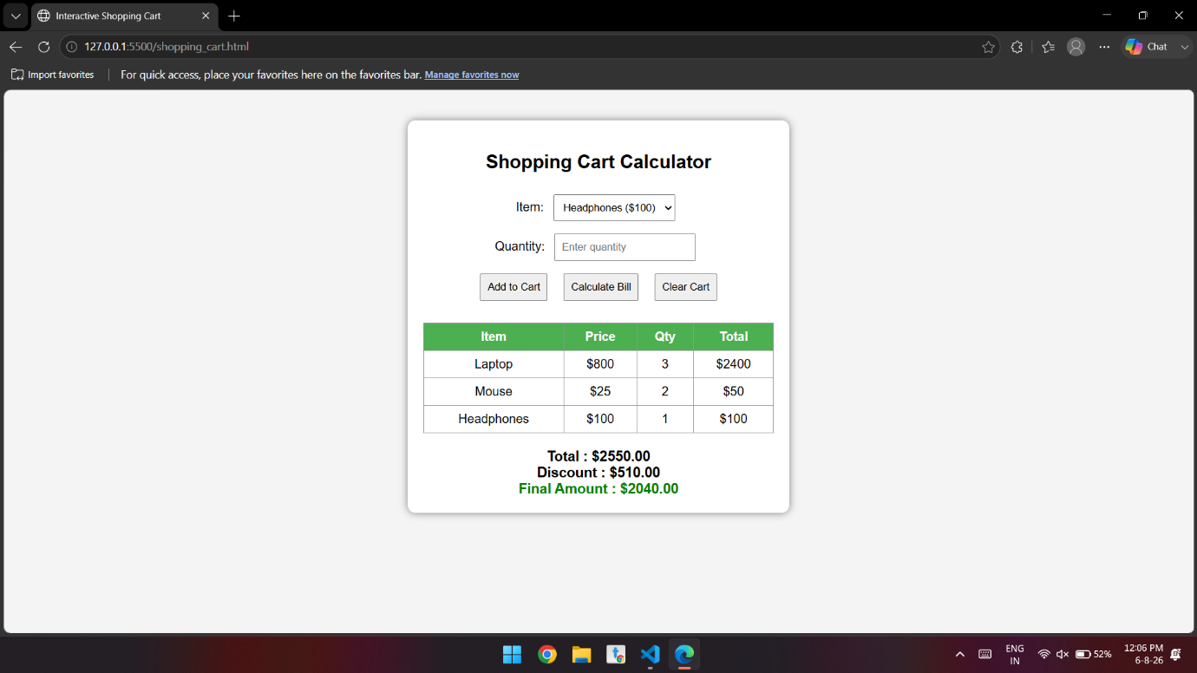

Conclusion:-
The experiment successfully demonstrates the use of arrays, objects, map(), reduce(), and conditional statements in JavaScript to create a cart total calculator. The program can calculate individual product subtotals, determine the overall cart value, and apply discounts according to predefined conditions. This provides a practical understanding of how array methods and object handling can be used to solve real-world programming problems while keeping the code organized, reusable, and efficient.

Case study – 5

Aim:-
To develop a JavaScript-based Array Calculator that accepts numbers from the user and finds the maximum and minimum values in the array.

Software/Tools Required:-
- Visual Studio Code (or any text editor)
- Web Browser (Google Chrome/Microsoft Edge)
- HTML, CSS, and JavaScript

Code:-
<!DOCTYPE html>
<html>
<head>
<title>Array Maximum and Minimum</title>

<style>
* {
box-sizing: border-box;
}

body {
font-family: Arial, sans-serif;
background: linear-gradient(135deg, #dff7f2, #cde9ff);
margin: 0;
padding: 0;
display: flex;
justify-content: center;
align-items: center;
min-height: 100vh;
}

.container {
background: rgba(255, 255, 255, 0.95);
width: 450px;
padding: 35px;
border-radius: 20px;

box-shadow:
0 15px 40px rgba(60, 120, 130, 0.18);

text-align: center;
}

h1 {
color: #17494d;
font-size: 30px;
margin-bottom: 10px;
}

p {
color: #6b7f82;
}

input {
width: 80%;
padding: 14px;
margin: 12px;
border: 2px solid #d5e8e6;
border-radius: 10px;

font-size: 16px;

background-color: #f7fcfb;
color: #17494d;

transition: 0.3s;
}

input:focus {
outline: none;
border-color: #52b8ae;

box-shadow:
0 0 0 3px rgba(82, 184, 174, 0.15);
}

input::placeholder {
color: #9aabab;
}

button {
padding: 12px 20px;
margin: 8px;

border: none;
border-radius: 10px;

background-color: #42a89d;
color: white;

font-size: 15px;
font-weight: 600;

cursor: pointer;

transition: 0.25s;
}

button:hover {
background-color: #328f86;
transform: translateY(-2px);

box-shadow:
0 6px 15px rgba(66, 168, 157, 0.25);
}

.result {
margin-top: 25px;
padding: 20px;

background-color: #f0faf8;

border: 1px solid #d6eeea;
border-radius: 14px;

display: none;
}

.result h3 {
color: #17494d;
margin-top: 0;
}

.maximum {
color: #23866d;
font-weight: bold;
}

.minimum {
color: #e06c5f;
font-weight: bold;
}
</style>
</head>

<body>

<div class="container">

<h1>Array Calculator</h1>

<p>Enter numbers separated by commas</p>

<input
type="text"
id="numbers"
placeholder="Example: 25, 10, 45, 5, 30, 15"
>

<br>

<button onclick="findMaxMin()">
Find Maximum & Minimum
</button>

<button onclick="clearData()">
Clear
</button>

<div class="result" id="result"></div>

</div>

<script>

function findMaxMin() {

// Get input from user
let input = document.getElementById("numbers").value;

// Check if input is empty
if (input.trim() === "") {
alert("Please enter some numbers!");
return;
}

// Convert input into an array
let numbers = input.split(",").map(Number);

// Check for invalid numbers
if (numbers.some(isNaN)) {
alert("Please enter only valid numbers!");
return;
}

// Find maximum and minimum
let maximum = numbers[0];
let minimum = numbers[0];

for (let i = 1; i < numbers.length; i++) {

if (numbers[i] > maximum) {
maximum = numbers[i];
}

if (numbers[i] < minimum) {
minimum = numbers[i];
}
}

// Display result
document.getElementById("result").style.display = "block";

document.getElementById("result").innerHTML =
"<h3>Result</h3>" +
"<p><b>Array:</b> [" + numbers.join(", ") + "]</p>" +
"<p class='maximum'>Maximum Value: " + maximum + "</p>" +
"<p class='minimum'>Minimum Value: " + minimum + "</p>";
}

function clearData() {

document.getElementById("numbers").value = "";

document.getElementById("result").style.display = "none";
}

</script>

</body>
</html>

Theory:-
An array is a collection of multiple values stored in a single variable. In this program, the input numbers are separated by commas and converted into an array using split() and map(Number). A for loop compares each element to find the maximum and minimum values. JavaScript functions are used to perform the calculation and clear the input data.

Output:-
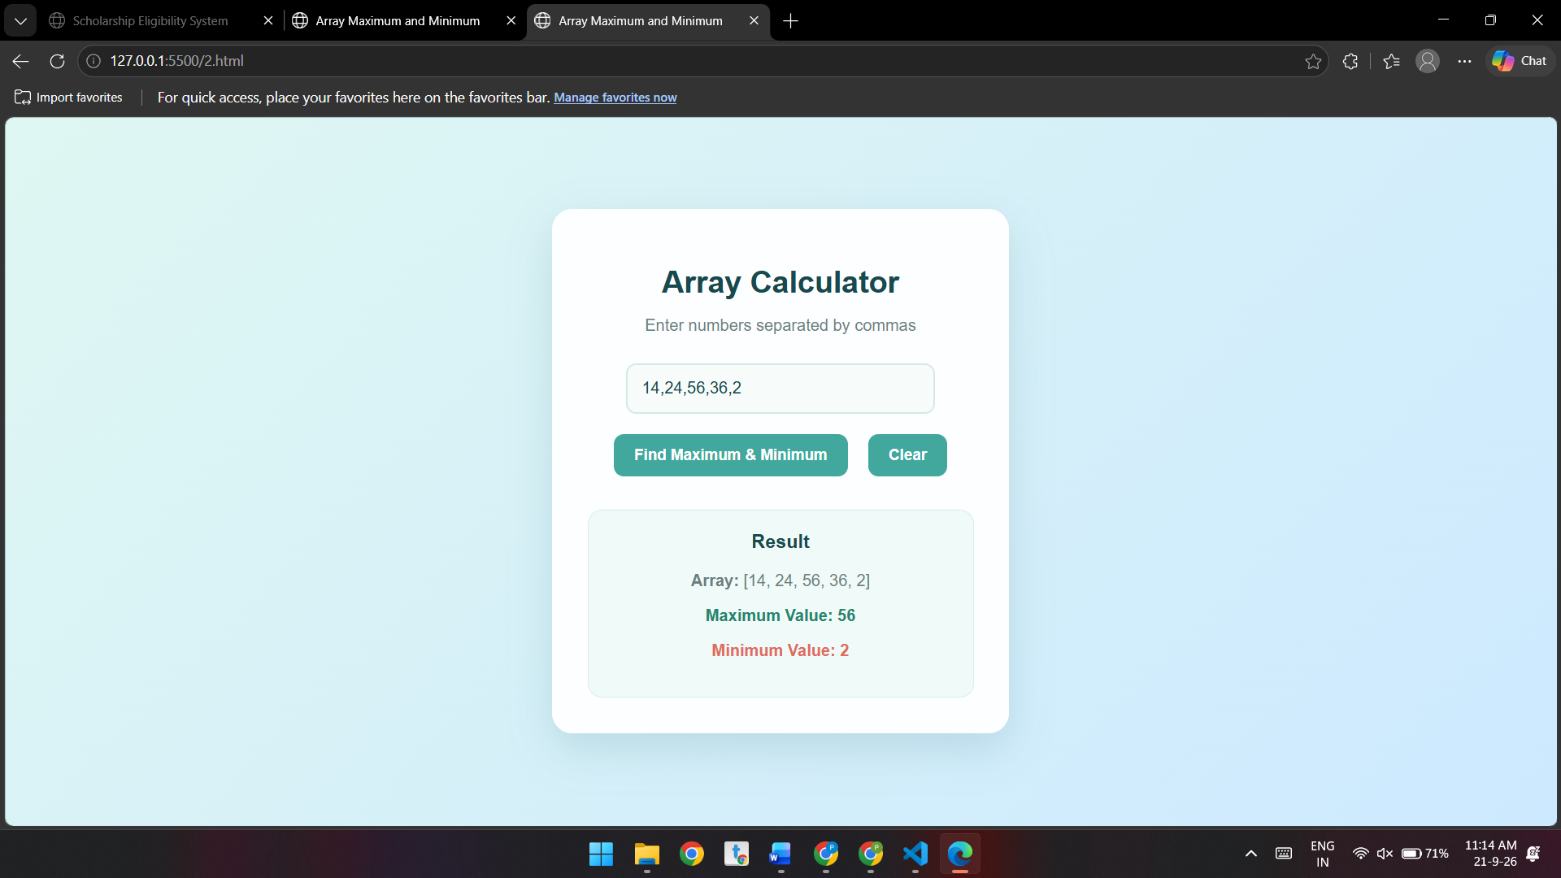

Conclusion:-
The program successfully accepts an array of numbers and calculates its maximum and minimum values using JavaScript. It also performs input validation and provides a clear and simple way to display the results.

Experiment – 6

Aim:-
Use string functions and regex for email validation, data extraction, and text analysis.

Software/Tools Required:-
- Visual Studio Code (or any text editor)
- Web Browser (Google Chrome/Microsoft Edge)
- HTML, CSS, and JavaScript

Code:-
<!DOCTYPE html>
<html>
<head>
<meta charset="utf-8">
<title>Text Processing</title>
<style>
body {
font-family:Arial,sans-serif;
margin:16px;
font-size:14px
}
.b {
border:1px solid #ddd;
border-radius:4px;
padding:16px;
margin:16px 0
}
input,textarea {
display:block;
margin:12px 0;
width:225px;
padding:4px
}
textarea {
height:44px
}
em {
display:block;
margin-top:8px
}
.ok {
color:green
}
.no {
color:#c00
}
</style>
</head>
<body>
<h3>PRN:24070521224</h3>
<h2>Text Processing</h2>
<div class="b">
<h3>1. Email Validation</h3>
<input id="e" value="example@gmail.com">
<button onclick="v()">Validate</button>
<em id="r1"></em>
</div>
<div class="b">
<h3>2. Data Extraction (Extract Numbers)</h3>
<input id="n" value="hello 12 5 7">
<button onclick="x()">Extract</button>
<em id="r2"></em>
</div>
<div class="b">
<h3>3. Text Analysis (Word Count &amp; Uppercase)</h3>
<textarea id="t">lorem ipsum dolor sit amet consectetur adipiscing elit in dolore et id voluptas et cupiditate quibusdam libero qui laborum nobis corrupti non exercitation irure qui similique assumenda pariatur et placeat nam vero voluptatum odio placeat praesentium ad et maxime temporibus est pariatur cupidatat deserunt at irure qui in atque excepturi</textarea>
<button onclick="a()">Analyze</button>
<em id="r3"></em><em id="r4"></em>
</div>
<script>
function v() {
const s=e.value.trim(),ok=/^[^\s@]+@[^\s@]+\.[^\s@]+$/.test(s);
r1.className=ok?'ok':'no';
r1.textContent=ok?'Valid email address.':'Invalid email address.'
}
function x() {
const m=n.value.match(/\d+/g);
r2.textContent='Extracted numbers: '+(m?m.join(', '):'none found')
}
function a() {
const s=t.value.trim();
r3.textContent='Word Count: '+(s?s.split(/\s+/).length:0);
r4.textContent='Uppercase: '+s.toUpperCase()
}
v();
x();
a();
</script>
</body>
</html>

Output:-
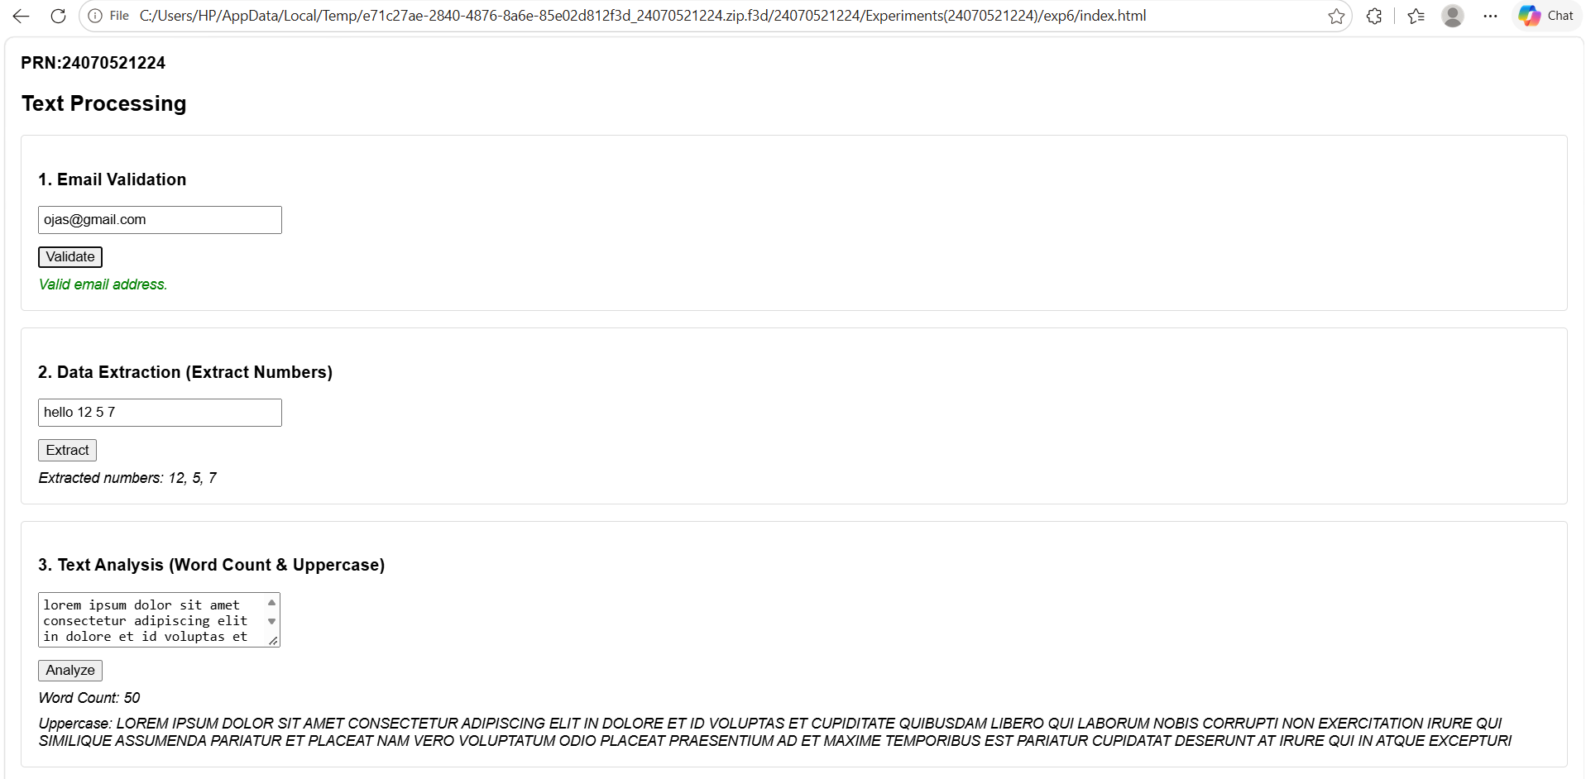

Conclusion:-
The experiment successfully demonstrated the use of string functions and regular expressions for email validation, data extraction, and text analysis. It showed that JavaScript provides efficient tools for processing and analyzing text data.

Case study – 6
Aim
To develop a JavaScript program for performing string operations, specifically to reverse a string and count the number of vowels present in a paragraph.

Software/Tools Required:-
- Visual Studio Code (or any text editor)
- Web Browser (Google Chrome/Microsoft Edge)
- HTML, CSS, and JavaScript

Code:-
<!DOCTYPE html>
<html>
<head>
<meta charset="utf-8">
<title>String Operations</title>
<style>
body {
font-family:Inter,Arial,sans-serif;
background:#f7f8fa;
margin:0;
color:#222
}
.w {
max-width:600px;
margin:30px auto
}
.h {
display:flex;
justify-content:space-between;
align-items:center;
border-bottom:1px solid #ddd;
padding-bottom:16px
}
.h h1 {
margin:0
}
.p {
background:#e9ebef;
padding:8px 12px;
border-radius:4px;
font-size:14px
}
.c {
background:#fff;
border:1px solid #e3e5e8;
border-radius:8px;
padding:20px;
margin-top:24px
}
label {
font-size:13px;
font-weight:600;
display:block;
margin:18px 0 8px
}
input,textarea {
width:100%;
box-sizing:border-box;
padding:10px;
border:1px solid #ddd;
border-radius:4px;
font:inherit
}
textarea {
height:75px
}
button {
background:#4f7df3;
color:#fff;
border:0;
padding:10px 14px;
border-radius:4px;
margin-top:14px;
cursor:pointer
}
.o {
font-family:monospace;
font-size:13px;
background:#f3f4f6;
border-left:3px solid #4f7df3;
padding:14px;
margin-top:16px
}
hr {
border:0;
border-top:1px solid #e5e5e5;
margin:28px 0 0
}
</style>
</head>
<body>
<div class="w">
<div class="h">
<h1>String Operations</h1>
<span class="p">PRN:24070521224</span>
</div>
<div class="c">
<h3>String Operations &amp; Vowel Counter</h3>
<label>1. Reverse a String</label>
<input id="s" value="JavaScript is awesome">
<button onclick="rv()">Reverse String</button>
<div class="o" id="o1"></div>
<hr>
<label>2. Count Vowels in a Paragraph</label>
<textarea id="p">The quick brown fox jumps over the lazy dog. Programming is a fun challenge!</textarea>
<button onclick="cv()">Count Vowels</button>
<div class="o" id="o2"></div>
</div>
</div>
<script>
function rv() {
o1.textContent='Reversed: '+[...s.value].reverse().join('')
}
function cv() {
const m=p.value.match(/[aeiou]/gi);
o2.textContent='Total Vowels: '+(m?m.length:0)
}
rv();
cv()
</script>
</body>
</html>

Output:-
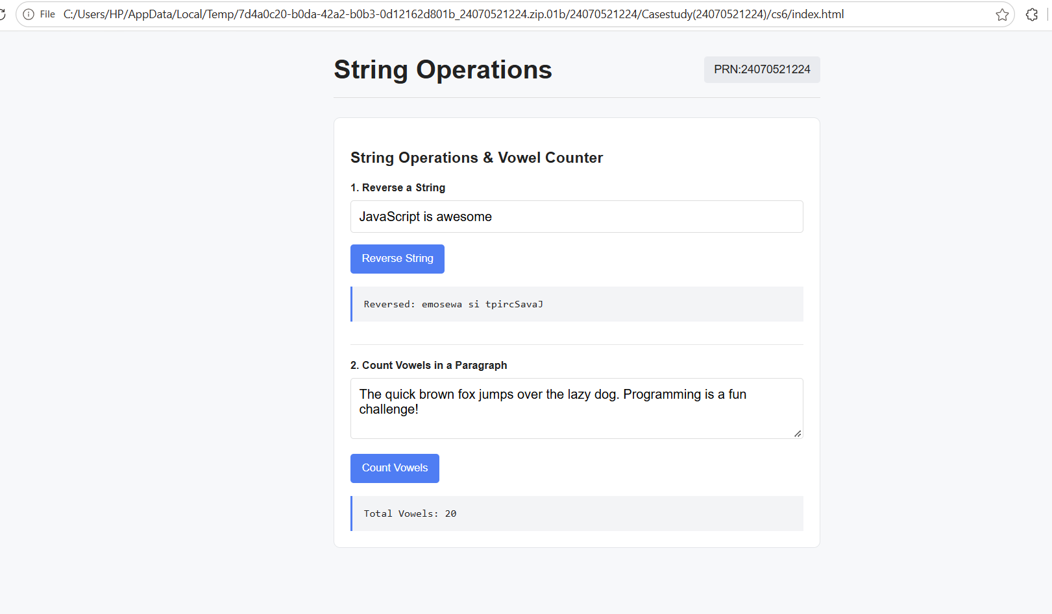

Conclusion
The program successfully performs basic string operations in JavaScript. It reverses the entered string and counts the number of vowels in a paragraph using functions and loops. It also displays a message when no input is provided, demonstrating basic input validation.

Experiment – 7

Aim:-
Perform DOM traversal and updates; develop a to-do list app with add, edit, and delete features.

Software/Tools Required:-
- Visual Studio Code (or any text editor)
- Web Browser (Google Chrome/Microsoft Edge)
- HTML, CSS, and JavaScript

Code:-
<!DOCTYPE html>
<html>
<head>
<meta charset="utf-8">
<title>My Tasks</title>
<style>
body {
font-family:Arial,sans-serif;
background:#f3f3f8;
margin:0
}
.c {
width:380px;
margin:64px auto;
background:#fff;
border:1px solid #ddd;
border-radius:6px;
padding:16px
}
h1 {
font-size:24px;
color:#444;
margin:12px 0
}
.a {
display:flex
}
.a input {
flex:1;
padding:8px;
border:1px solid #ccc
}
.a button {
padding:8px 10px;
border:1px solid #ccc;
background:#e9e9ee
}
li {
display:flex;
align-items:center;
gap:10px;
padding:10px 6px;
border-bottom:1px solid #eee;
list-style:none
}
li span {
flex:1
}
.d {
text-decoration:line-through;
color:#999
}
ul {
padding:0;
margin:16px 0 0
}
li button {
font-size:11px;
padding:3px 7px
}
</style>
</head>
<body>
<div class="c"><b>PRN:24070521224</b>
<h1>My Tasks</h1>
<div class="a">
<input id="i" placeholder="Enter a new task...">
<button onclick="add()">Add Task</button>
</div>
<ul id="l"></ul>
</div>
<script>
let T=[{t:'homework',d:false},{t:'assignment',d:true}];
function draw() {
l.innerHTML='';
T.forEach((k,i)=> {
const li=document.createElement('li');
li.innerHTML=`<input type=checkbox ${k.d?'checked':''}><span class="${k.d?'d':''}"></span><button>Edit</button><button>Delete</button>`;
li.querySelector('span').textContent=k.t;
const[c,,e,d]=[...li.children];
c.onchange=()=> {
k.d=c.checked;
draw()
};
e.onclick=()=> {
const n=prompt('Edit task',k.t);
if(n&&n.trim()) {
k.t=n.trim();
draw()
}
};
d.onclick=()=> {
T.splice(i,1);
draw()
};
l.appendChild(li)
})
}
function add() {
const v=i.value.trim();
if(!v)return;
T.push({t:v,d:false});
i.value='';
draw()
}
i.onkeydown=e=> {
if(e.key==='Enter')add()
};
draw()
</script>
</body>
</html>

Output:-
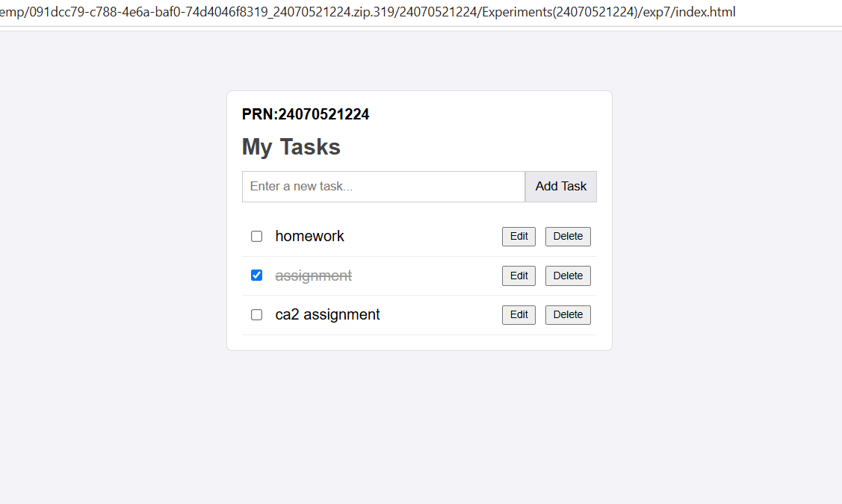

Conclusion:-
The To-Do List application was successfully implemented using HTML, CSS, and JavaScript. It demonstrated **DOM manipulation and event handling** through add, edit, delete, and complete features. The experiment helped in understanding how JavaScript creates dynamic and interactive web pages.

Case Study – 7
Aim
To develop a JavaScript-based registration form that accepts user details and performs validation for required fields, birthday, email, website, password, and terms and conditions.

Software/Tools Required:-
- Visual Studio Code (or any text editor)
- Web Browser (Google Chrome/Microsoft Edge)
- HTML, CSS, and JavaScript

Code:-
<!DOCTYPE html>
<html>
<head>
<meta charset="utf-8">
<title>Register</title>
<style>
body {
font-family:'Courier New',monospace;
background:#fafaf7;
margin:0
}
.f {
width:280px;
margin:30px auto
}
.t {
display:flex;
justify-content:space-between;
align-items:center;
border-bottom:2px solid #111;
padding-bottom:6px;
margin-bottom:14px
}
h1 {
font-size:15px;
margin:0
}
.p {
background:#111;
color:#fff;
font-size:10px;
padding:3px 6px
}
label {
display:block;
font-size:8px;
font-weight:bold;
margin:12px 0 4px
}
input[type=text],input[type=email],input[type=url],input[type=password] {
width:100%;
box-sizing:border-box;
height:28px;
border:1px solid #111;
background:#fff;
padding:4px;
font:inherit
}
.pre {
background:#e8efff!important
}
.r {
display:flex;
gap:6px
}
select {
flex:1;
height:28px;
border:1px solid #111;
background:#fff;
font:inherit;
font-size:9px
}
.e {
font-size:9px;
margin-top:3px;
color:#c00
}
button {
width:100%;
background:#111;
color:#fff;
border:0;
height:34px;
font:bold 10px monospace;
margin-top:14px
}
.k {
font-size:9px;
margin-top:14px
}
</style>
</head>
<body>
<form class="f" id="f" novalidate>
<div class="t">
<h1>REGISTER</h1>
<span class="p">PRN:24070521224</span>
</div>
<label>FIRSTNAME *</label>
<input class="pre" type="text" id="fn" value="OJAS">
<label>LASTNAME</label>
<input class="pre" type="text" id="ln" value="BHAISARE">
<label>BIRTHDAY *</label>
<div class="r">
<select id="dd"><option value="">DD</option></select>
<select id="mm"><option value="">MM</option></select>
<select id="yy"><option value="">YYYY</option></select>
</div>
<label>USERNAME *</label>
<input type="text" id="un">
<label>E-MAIL *</label>
<input type="email" id="em">
<label>WEBSITE *</label>
<input type="url" id="ws" placeholder="https://">
<label>PASSWORD *</label>
<input type="password" id="pw">
<label>RE-PASSWORD *</label>
<input type="password" id="rp">
<div class="k">
<input type="checkbox" id="tc">
I agree to the terms and conditions
</div>
<div class="e" id="er"></div>
<button>SUBMIT</button>
</form>
<script>
for(let i=1;i<=31;i++)dd.add(new Option(String(i).padStart(2,'0'),i));
for(let i=1;i<=12;i++)mm.add(new Option(String(i).padStart(2,'0'),i));
for(let y=2012;y>=1950;y--)yy.add(new Option(y,y));
f.onsubmit=e=> {
e.preventDefault();
const m=[];
if(!fn.value.trim())m.push('First name is required');
if(!dd.value||!mm.value||!yy.value)m.push('Select your birthday');
if(!/^\w{4,}$/.test(un.value))m.push('Username: 4+ letters, digits or _');
if(!/^[^\s@]+@[^\s@]+\.[^\s@]+$/.test(em.value))m.push('Enter a valid e-mail');
if(!/^https?:\/\/.+\..+/.test(ws.value))m.push('Enter a valid website URL');
if(pw.value.length<8)m.push('Password needs 8+ characters');
if(pw.value!==rp.value)m.push('Passwords do not match');
if(!tc.checked)m.push('Accept the terms to continue');
er.innerHTML=m.join('<br>');
if(!m.length) {
er.style.color='green';
er.textContent='Registration successful, '+fn.value+'!'
} else er.style.color='#c00'
}
</script>
</body>
</html>

Output:-
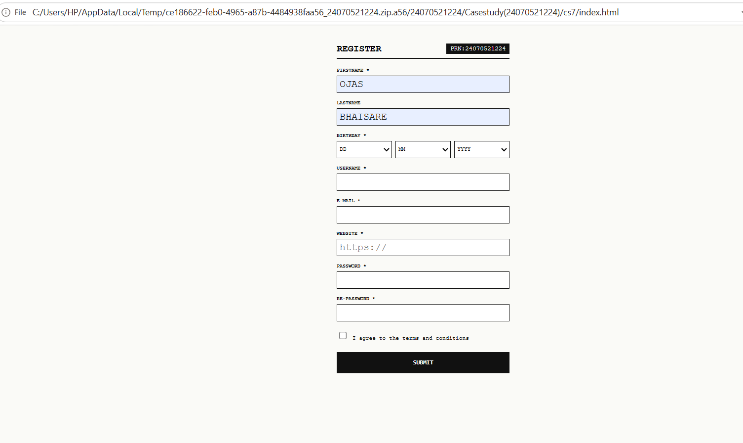

Conclusion
The program successfully implements a user registration form with JavaScript validation. It prevents incorrect or incomplete data from being submitted and displays appropriate messages for invalid inputs. This demonstrates the practical use of form handling, event handling, input validation, conditions, and regular expressions in JavaScript.

Experiment – 8

Aim:-
Access and validate form fields using events; design a gym admission form with live input checks.

Software/Tools Required:-
- Visual Studio Code (or any text editor)
- Web Browser (Google Chrome/Microsoft Edge)
- HTML, CSS, and JavaScript

Code:-
<!DOCTYPE html>
<html>
<head>
<meta charset="utf-8">
<title>Join the Club</title>
<style>
body {
font-family:Outfit,Arial,sans-serif;
background:#f3f4f6;
margin:0
}
.c {
width:265px;
margin:28px auto;
background:#fff;
border-radius:14px;
padding:24px 30px;
position:relative;
box-shadow:0 2px 10px #0001
}
.p {
position:absolute;
top:14px;
right:14px;
background:#eee;
border-radius:12px;
font-size:10px;
padding:3px 8px;
color:#555
}
h2 {
text-align:center;
margin:20px 0 4px
}
.s {
text-align:center;
font-size:11px;
color:#777;
margin-bottom:22px
}
label {
display:block;
font-size:10px;
font-weight:600;
margin:14px 0 6px
}
input,select {
width:100%;
box-sizing:border-box;
padding:9px;
border:1px solid #ccc;
border-radius:6px;
font:inherit;
font-size:12px
}
.ok {
border-color:#5cc98a
}
.bad {
border-color:#e55
}
.m {
color:#e55;
font-size:10px;
min-height:12px
}
button {
width:100%;
background:#4f46e5;
color:#fff;
border:0;
border-radius:6px;
padding:11px;
font-weight:600;
margin-top:20px
}
#ok {
color:#16a34a;
text-align:center;
font-size:12px;
margin-top:10px
}
</style>
</head>
<body>
<form class="c" id="f" novalidate><span class="p">PRN:24070521224</span>
<h2>Join the Club</h2>
<div class="s">Start your fitness journey today.</div>
<label>Full Name</label>
<input id="n" value="Ojas Bhaisare">
<div class="m"></div>
<label>Email Address</label>
<input id="e" value="ojas@gmail.com">
<div class="m"></div>
<label>Phone Number</label>
<input id="p" value="9876543210">
<div class="m"></div>
<label>Age</label>
<input id="a" value="19">
<div class="m"></div>
<label>Membership Plan</label>
<select id="pl" class="ok"><option>Basic (1 Month)</option><option>Standard (3 Months)</option><option>Premium (12 Months)</option></select>
<button>Submit Application</button>
<div id="ok"></div>
</form>
<script>
const R=[[n,v=>v.trim().length>=2,'Enter your full name'],[e,v=>/^[^\s@]+@[^\s@]+\.[^\s@]+$/.test(v),'Enter a valid email'],[p,v=>/^[6-9]\d{9}$/.test(v),'Enter a 10-digit mobile number'],[a,v=>+v>=14&&+v<=80,'Age must be 14 to 80']];
function chk() {
let all=true;
R.forEach(([i,t,m])=> {
const g=t(i.value);
all=all&&g;
i.className=g?'ok':'bad';
i.nextElementSibling.textContent=g?'':m
});
return all
}
R.forEach(([i])=>i.oninput=chk);
chk();
f.onsubmit=x=> {
x.preventDefault();
ok.textContent=chk()?'Application submitted. Welcome, '+n.value.trim()+'!':''
}
</script>
</body>
</html>

Output:-

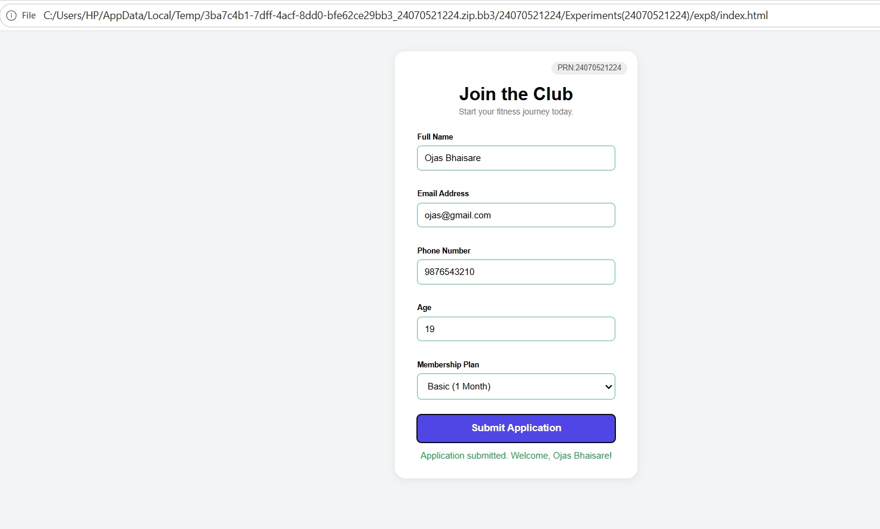

Conclusion:-
The gym admission form was successfully implemented with event-based live validation. It provides immediate feedback for invalid inputs and accepts the form only when all required details are valid.

Case Study – 8

Aim
To design and develop a Job Application Form using HTML and CSS and implement JavaScript-based form validation to ensure that the entered information is valid and all required fields are completed.

Software/Tools Required:-
- Visual Studio Code (or any text editor)
- Web Browser (Google Chrome/Microsoft Edge)
- HTML, CSS, and JavaScript

Code:-
<!DOCTYPE html>
<html>
<head>
<meta charset="utf-8">
<title>Job Application Form</title>
<style>
body {
font-family:Inter,Arial,sans-serif;
background:#f6f7f9;
margin:0;
color:#111
}
.w {
max-width:600px;
margin:20px auto
}
.pr {
text-align:center;
color:#666;
font-size:12px
}
h1 {
text-align:center;
margin:8px 0 18px
}
.c {
background:#fff;
border:1px solid #e5e7eb;
border-radius:12px;
padding:20px
}
h3 {
font-size:14px;
margin:6px 0 14px;
border-bottom:1px solid #eee;
padding-bottom:8px
}
.g {
display:grid;
grid-template-columns:1fr 1fr;
gap:12px 20px;
margin-bottom:20px
}
.g.t {
grid-template-columns:1fr 1fr 1fr
}
.s {
grid-column:1/-1
}
label {
font-size:10px;
font-weight:600;
color:#1f2a44;
display:block;
margin-bottom:4px
}
input,select,textarea {
width:100%;
box-sizing:border-box;
border:1px solid #ddd;
border-radius:6px;
padding:8px;
font:inherit;
font-size:11px
}
textarea {
height:40px
}
button {
width:100%;
background:#111827;
color:#fff;
border:0;
border-radius:6px;
padding:11px
}
</style>
</head>
<body>
<div class="w">
<div class="pr">PRN:24070521224</div>
<h1>Job Application Form</h1>
<form class="c" id="f">
<h3>Personal Information</h3>
<div class="g">
<div>
<label>Full Name *</label>
<input id="fn" value="Ojas Bhaisare" required>
</div>
<div>
<label>Date of Birth *</label>
<input type="date" required>
</div>
<div>
<label>Gender *</label>
<select required><option value="">Select Gender</option><option>Male</option><option>Female</option><option>Other</option></select>
</div>
<div>
<label>Email Address *</label>
<input type="email" required>
</div>
<div>
<label>Mobile Number *</label>
<input pattern="[0-9]{10}" placeholder="10-digit number" required>
</div>
<div></div>
<div class="s">
<label>Address *</label>
<textarea required></textarea>
</div>
</div>
<div class="g t">
<div>
<label>City *</label>
<input required>
</div>
<div>
<label>State *</label>
<input required>
</div>
<div>
<label>PIN Code *</label>
<input pattern="[0-9]{6}" placeholder="6-digit PIN" required>
</div>
</div>
<h3>Educational Qualification</h3>
<div class="g">
<div>
<label>Highest Qualification *</label>
<select required><option value="">Select Qualification</option><option>Diploma</option><option>B.Tech</option><option>M.Tech</option></select>
</div>
<div>
<label>University/Institute *</label>
<input required>
</div>
<div>
<label>Passing Year *</label>
<input type="number" min="1990" max="2030" required>
</div>
<div>
<label>Percentage/CGPA *</label>
<input required>
</div>
</div>
<h3>Professional Information</h3>
<div class="g">
<div>
<label>Applying For / Job Position *</label>
<input required>
</div>
<div>
<label>Total Work Experience (Years) *</label>
<input type="number" min="0" required>
</div>
<div>
<label>Current/Previous Organization</label>
<input>
</div>
<div>
<label>Current Designation</label>
<input>
</div>
<div>
<label>Expected Salary</label>
<input>
</div>
</div>
<h3>Technical Skills</h3>
<div class="g">
<div class="s">
<label>Programming Languages *</label>
<textarea placeholder="e.g., JavaScript, Python, Java" required></textarea>
</div>
<div class="s">
<label>Technical Skills *</label>
<textarea placeholder="e.g., React, Node.js, Docker" required></textarea>
</div>
<div class="s">
<label>Certifications</label>
<textarea placeholder="e.g., AWS Certified Solutions Architect"></textarea>
</div>
</div>
<button>Submit Application</button>
</form>
</div>
<script>
f.onsubmit=e=> {
e.preventDefault();
alert('Application submitted for '+fn.value)
}
</script>
</body>
</html>

Output:-
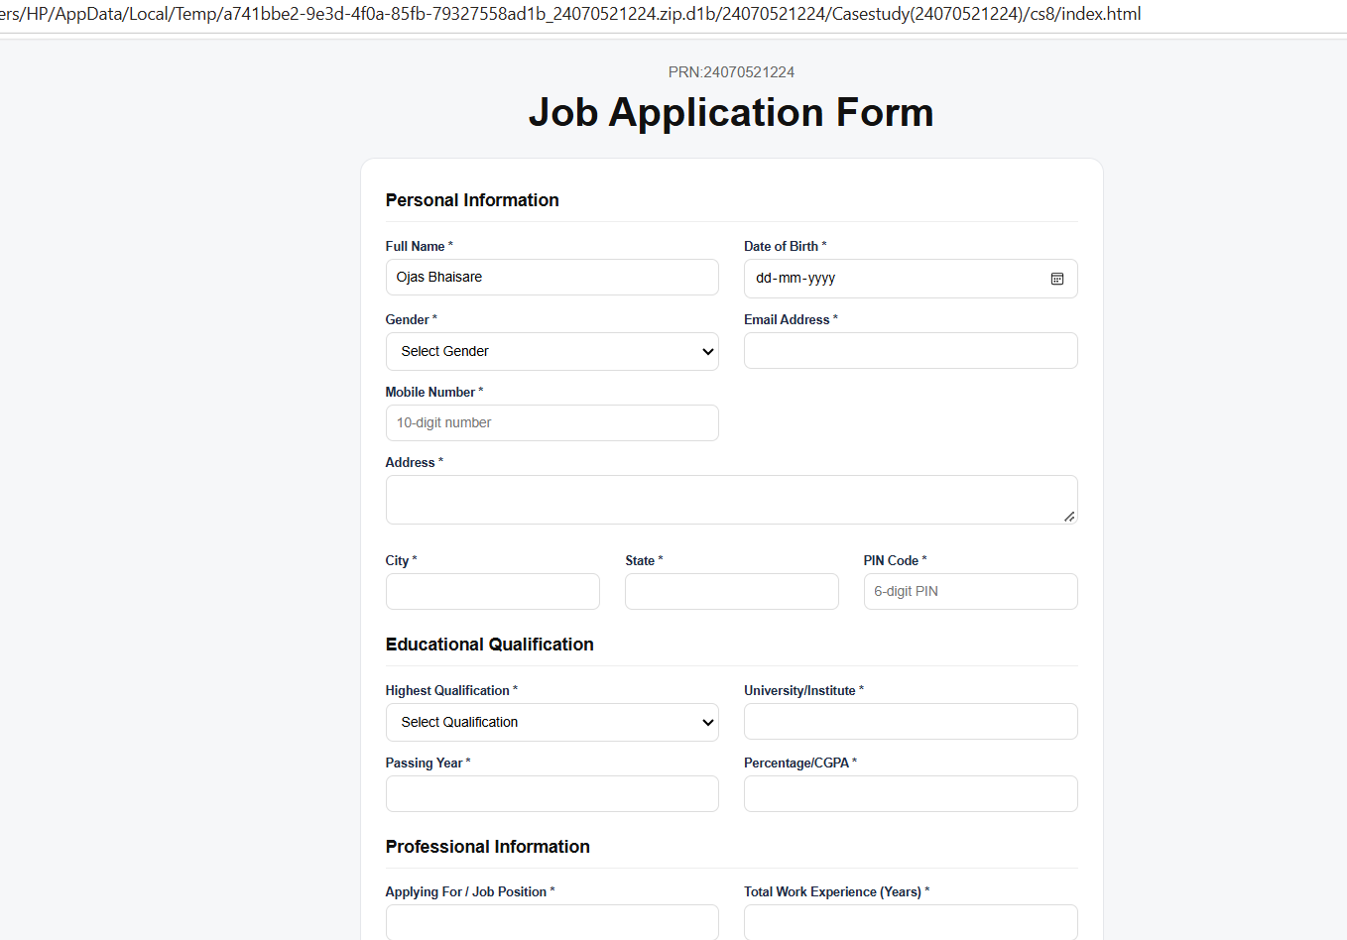
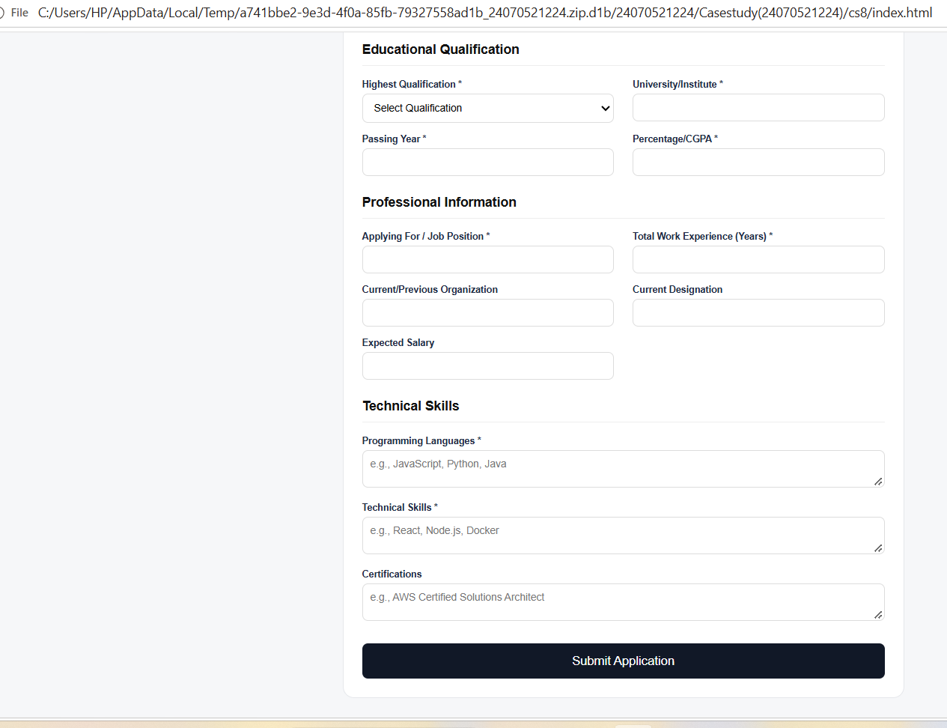

Conclusion
The Job Application Form was successfully designed and implemented using HTML, CSS, and JavaScript. The form accepts personal, educational, professional, and technical information and performs client-side validation to identify incorrect or missing inputs. Thus, the experiment demonstrates the use of HTML for structure, CSS for presentation, and JavaScript for interactive form validation.

Experiment – 9

Aim:-
Implement localStorage and sessionStorage to save user preferences like theme settings.

Software/Tools Required:-
- Visual Studio Code (or any text editor)
- Web Browser (Google Chrome/Microsoft Edge)
- HTML, CSS, and JavaScript

Code:-
<!DOCTYPE html>
<html>
<head>
<meta charset="utf-8">
<title>Dashboard Settings</title>
<style>
body {
font-family:Inter,Arial,sans-serif;
background:#f4f5f7;
margin:0;
display:flex;
justify-content:center;
align-items:center;
height:100vh;
transition:.2s
}
body.d {
background:#15171c;
color:#eee
}
.c {
background:#fff;
border-radius:16px;
padding:26px;
width:260px;
box-shadow:0 4px 20px #0001;
text-align:center
}
.d .c {
background:#22252c
}
.p {
display:inline-block;
border:1px solid #e5e7eb;
border-radius:14px;
padding:6px 18px;
background:#f4f5f7;
color:#444;
margin:8px 0 18px
}
.r {
display:flex;
justify-content:space-between;
align-items:center;
text-align:left
}
.r small {
color:#888;
font-size:10px
}
.sw {
width:32px;
height:18px;
background:#ccc;
border-radius:9px;
position:relative;
cursor:pointer
}
.sw:after {
content:'';
position:absolute;
top:2px;
left:2px;
width:14px;
height:14px;
border-radius:50%;
background:#fff;
transition:.2s
}
.sw.on {
background:#4f7df3
}
.sw.on:after {
left:16px
}
.b {
display:flex;
gap:10px;
margin:16px 0
}
.b button {
flex:1;
padding:10px 4px;
border-radius:6px;
border:1px solid #ddd;
background:#fff;
font-size:12px
}
.b button:first-child {
background:#4f7df3;
color:#fff;
border-color:#4f7df3
}
#m {
background:#eef2ff;
color:#4f7df3;
border-radius:6px;
padding:12px;
font-size:12px
}
</style>
</head>
<body>
<div class="c">
<h2 style="margin:0">Dashboard Settings</h2>
<div class="p">PRN:24070521224</div>
<div class="r">
<div>Dark Appearance<br><small>Use buttons below to save preference</small></div>
<div class="sw" id="sw"></div>
</div>
<div class="b">
<button onclick="sv(localStorage,'localStorage')">Save to Local</button>
<button onclick="sv(sessionStorage,'sessionStorage')">Save to Session</button>
</div>
<div id="m">No preference saved yet</div>
</div>
<script>
function ap(d) {
document.body.classList.toggle('d',d);
sw.classList.toggle('on',d)
}
sw.onclick=()=>ap(!sw.classList.contains('on'));
function sv(s,n) {
try {
s.setItem('theme',sw.classList.contains('on')?'dark':'light');
m.textContent='Theme saved to '+n
} catch(e) {
m.textContent='Storage unavailable'
}
}
try {
const t=localStorage.getItem('theme')||sessionStorage.getItem('theme');
if(t) {
ap(t==='dark');
m.textContent='Loaded saved theme: '+t
}
} catch(e) {
}
</script>
</body>
</html>

Output:-
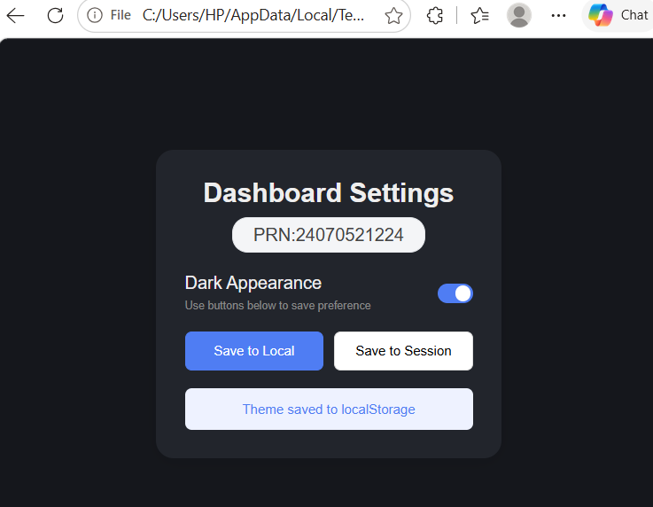

Conclusion:-
The experiment successfully demonstrates the use of localStorage and sessionStorage for storing user preferences such as theme settings. localStorage provides persistent storage, allowing preferences to remain available across browser sessions, whereas sessionStorage provides temporary storage for the current session.
Case Study – 9

Aim:
To implement and integrate the concepts studied from Experiment 1 to Experiment 8 to develop an interactive web page with Light and Dark Theme background switching using HTML, CSS, and JavaScript.

Software/Tools Required:-
- Visual Studio Code (or any text editor)
- Web Browser (Google Chrome/Microsoft Edge)
- HTML, CSS, and JavaScript

Theory
A web page can provide different visual themes using CSS and JavaScript. In the light theme, the page uses a light background with dark text, while in the dark theme, the background and content areas are changed to dark colors with white text.
JavaScript is used to dynamically change the theme. The toggleTheme() function adds or removes the dark-mode class from the <body> element using classList.toggle(). When dark mode is active, the button text changes to " Light Mode", and when light mode is active, it changes back to "Dark Mode".
CSS transitions are also used to make the theme change smoother. The experiment demonstrates how CSS provides the appearance of the themes while JavaScript provides interactive theme switching.

Code:-
<!DOCTYPE html>
<html lang="en">
<head>
<meta charset="UTF-8">
<meta name="viewport" content="width=device-width, initial-scale=1.0">
<title>Light and Dark Theme</title>
<style>
body{margin:0;font-family:Arial,sans-serif;background:#f5f7fb;color:#1f2937;transition:background .4s,color .4s}
.top{display:flex;justify-content:space-between;align-items:center;padding:16px 32px;background:#ffffff;border-bottom:1px solid #dde2ec;transition:background .4s,border-color .4s}
.top h1{font-size:20px;margin:0}
.info{font-size:13px;color:#555;transition:color .4s}
button{background:#3b6cf6;color:#fff;border:0;padding:9px 16px;border-radius:6px;cursor:pointer;font-size:14px}
.content{max-width:640px;margin:40px auto;padding:0 20px}
.box{background:#ffffff;border:1px solid #dde2ec;border-radius:10px;padding:22px;margin-bottom:20px;transition:background .4s,border-color .4s}
.box h2{margin-top:0}
body.dark-mode{background:#12151c;color:#f1f3f8}
body.dark-mode .top,body.dark-mode .box{background:#1c212b;border-color:#2e3542}
body.dark-mode .info{color:#b8bfce}
body.dark-mode button{background:#f1b84b;color:#12151c}
</style>
</head>
<body>
<div class="top">
<div>
<h1>Light and Dark Theme</h1>
<div class="info">Ojas Bhaisare | PRN:24070521224</div>
</div>
<button id="themeBtn" onclick="toggleTheme()">Dark Mode</button>
</div>
<div class="content">
<div class="box">
<h2>Welcome</h2>
<p>This page switches between a light theme and a dark theme using JavaScript and CSS transitions.</p>
</div>
<div class="box">
<h2>How it works</h2>
<p>The toggleTheme() function adds or removes the dark-mode class on the body element with classList.toggle(). The button text changes to match the active theme.</p>
</div>
</div>
<script>
function toggleTheme() {
const dark = document.body.classList.toggle("dark-mode");
document.getElementById("themeBtn").textContent = dark ? "\u2600 Light Mode" : "Dark Mode";
}
</script>
</body>
</html>

Output:-
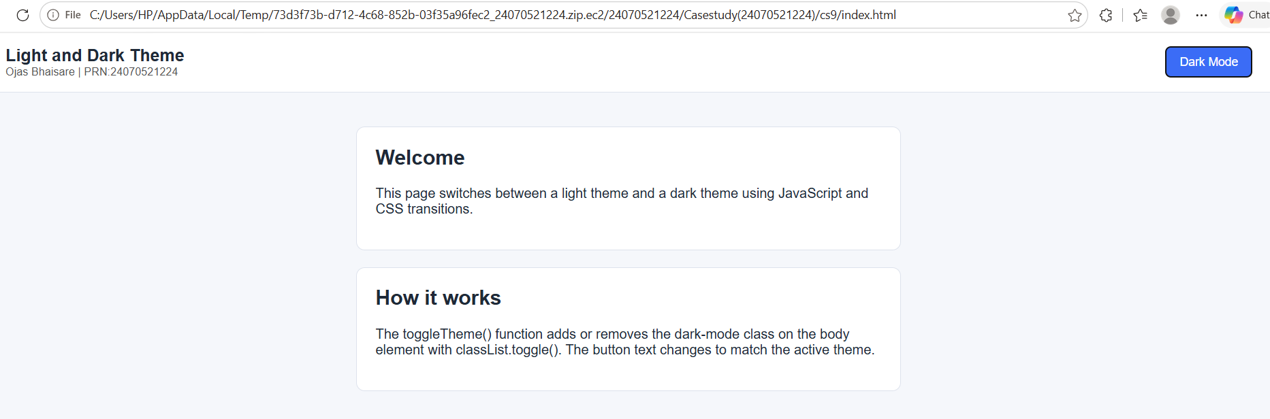
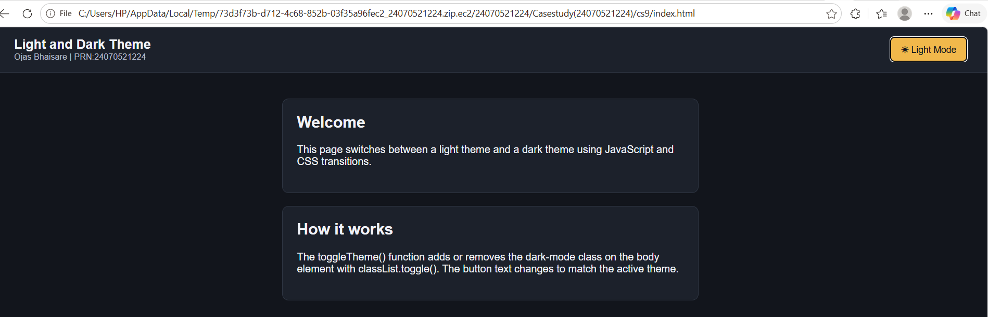

Conclusion
The Light and Dark Theme was successfully implemented using HTML, CSS, and JavaScript. The webpage switches between themes using a button, demonstrating CSS styling and JavaScript theme switching.

Experiment – 10

Aim:-
Load and display JSON data using fetch() and jQuery $.getJSON(); render results dynamically in a table.

Software/Tools Required:-
- Visual Studio Code (or any text editor)
- Web Browser (Google Chrome/Microsoft Edge)
- HTML, CSS, and JavaScript

Code:-
<!DOCTYPE html>
<html>
<head>
<meta charset="utf-8">
<title>JSON Data Fetcher</title>
<script src="https://cdnjs.cloudflare.com/ajax/libs/jquery/3.7.1/jquery.min.js"></script>
<style>
body {
font-family:Inter,Arial,sans-serif;
background:#f8f9fb;
margin:0;
color:#222
}
.c {
max-width:600px;
margin:30px auto;
background:#fff;
border-radius:12px;
box-shadow:0 2px 12px #0001;
overflow:hidden
}
.h {
padding:24px;
display:flex;
justify-content:space-between;
align-items:center
}
.h h1 {
margin:0;
font-size:20px
}
.h p {
margin:4px 0 0;
font-size:11px;
color:#777
}
.p {
background:#eaf0ff;
color:#4f7df3;
border:1px solid #cfdcff;
padding:10px 14px;
border-radius:6px;
font-size:13px
}
.bar {
background:#f4f5f8;
padding:14px 24px;
display:flex;
gap:10px
}
button {
border:0;
padding:9px 14px;
border-radius:5px;
font-size:12px;
color:#fff;
background:#4f7df3
}
.g {
background:#58b27a
}
.w {
background:#fff;
color:#333;
border:1px solid #ddd
}
table {
width:100%;
border-collapse:collapse;
font-size:12px
}
th {
text-align:left;
color:#777;
font-size:10px;
padding:16px 24px 10px;
border-bottom:2px solid #ddd
}
td {
padding:14px 24px;
border-bottom:1px solid #eee
}
td:first-child {
color:#777
}
td:last-child {
color:#4f7df3
}
.m {
text-align:center;
color:#999;
padding:30px
}
</style>
</head>
<body>
<div class="c">
<div class="h">
<div>
<h1>Network Request</h1>
<p>Retrieving external JSON placeholder data</p>
</div>
<span class="p">PRN:24070521224</span>
</div>
<div class="bar">
<button onclick="F()">Load with Fetch API</button>
<button class="g" onclick="J()">Load with jQuery $.getJSON</button>
<button class="w" onclick="X()">Clear Data</button>
</div>
<table>
<thead>
<tr><th>ID</th><th>NAME</th><th>USERNAME</th><th>EMAIL</th></tr>
</thead>
<tbody id="b">
<tr><td colspan="4" class="m">No data loaded. Use a button above.</td></tr>
</tbody>
</table>
</div>
<script>
const U='https://jsonplaceholder.typicode.com/users';
function R(d) {
b.innerHTML=d.map(u=>`<tr><td>#${u.id}</td><td><b></b></td><td>@${u.username}</td><td>${u.email}</td></tr>`).join('');
[...b.rows].forEach((r,i)=>r.querySelector('b').textContent=d[i].name)
}
function err() {
b.innerHTML='<tr><td colspan="4" class="m">Could not load data. Check your internet connection.</td></tr>'
}
function F() {
fetch(U).then(r=>r.json()).then(R).catch(err)
}
function J() {
$.getJSON(U,R).fail(err)
}
function X() {
b.innerHTML='<tr><td colspan="4" class="m">No data loaded. Use a button above.</td></tr>'
}
</script>
</body>
</html>

Output:-
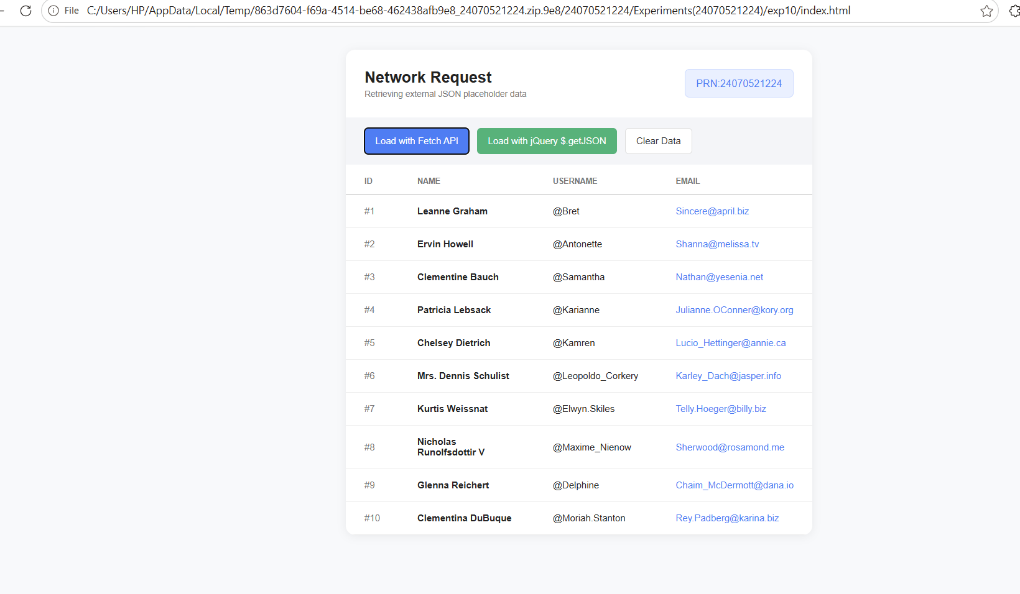

Conclusion:-
This experiment demonstrates how JSON, fetch(), $.getJSON(), and DOM manipulation are used to retrieve and dynamically display data in an HTML table. It provides practical understanding of JSON parsing and asynchronous data retrieval.

Case study – 10

Aim
To develop a Campus Event Registration System using HTML, CSS, JavaScript, JSON, Fetch API, and jQuery to load, display, search, and filter student registration data.

Software/Tools Required:-
- Visual Studio Code (or any text editor)
- Web Browser (Google Chrome/Microsoft Edge)
- HTML, CSS, and JavaScript

Code:-
<!DOCTYPE html>
<html>
<head>
<meta charset="utf-8">
<title>Event Registry</title>
<script src="https://cdnjs.cloudflare.com/ajax/libs/jquery/3.7.1/jquery.min.js"></script>
<style>
body {
font-family:Arial,sans-serif;
margin:0;
padding:24px 56px;
color:#111
}
.h {
display:flex;
justify-content:space-between;
align-items:baseline;
border-bottom:4px solid #111;
padding-bottom:12px
}
h1 {
margin:0;
font-size:22px
}
.st {
display:flex;
border:1px solid #111;
border-width:2px 0 1px;
margin:20px 0
}
.st div {
flex:1;
padding:10px 12px;
border-left:1px solid #111;
font-size:11px;
font-weight:bold
}
.st div:first-child {
border:0
}
.st b {
display:block;
font-size:26px;
margin-top:6px
}
.tb {
display:flex;
gap:10px;
margin-bottom:12px
}
.tb input {
flex:1;
padding:8px;
border:1px solid #111
}
.tb select,.tb button {
padding:8px 12px;
border:1px solid #111;
background:#fff;
font-weight:bold;
font-size:11px
}
table {
width:100%;
border-collapse:collapse;
font-size:12px
}
th {
background:#111;
color:#fff;
text-align:left;
padding:12px 10px;
font-size:11px
}
td {
padding:12px 10px;
border:1px solid #111
}
.tg {
font-weight:bold;
font-size:10px;
padding:4px 8px;
display:inline-block
}
.Registered {
background:#111;
color:#fff
}
.Pending {
border:1px dashed #111
}
.Cancelled {
background:#ddd;
color:#666;
text-decoration:line-through
}
</style>
</head>
<body>
<div class="h">
<h1>EVENT REGISTRY</h1>
<b>PRN:24070521224</b>
</div>
<div class="st">
<div>TOTAL<b id="t">0</b></div>
<div>REGISTERED<b id="r">0</b></div>
<div>PENDING<b id="p">0</b></div>
<div>CANCELLED<b id="c">0</b></div>
</div>
<div class="tb">
<input id="q" placeholder="Search by name or PRN...">
<select id="s"><option value="">All Statuses</option><option>Registered</option><option>Pending</option><option>Cancelled</option></select>
<button onclick="F()">LOAD (FETCH API)</button>
<button onclick="J()">LOAD (JQUERY)</button>
<button onclick="X()">RESET</button>
</div>
<table>
<thead>
<tr><th>#</th><th>PRN</th><th>STUDENT NAME</th><th>DEPARTMENT</th><th>YEAR</th><th>EVENT</th><th>STATUS</th></tr>
</thead>
<tbody id="b"></tbody>
</table>
<script>
const D=[["PRN24001","Alex Johnson","Computer Science","TE","Hackathon 2026","Registered"],["PRN24002","Sam Smith","Information Tech","TE","WebDev Sprint","Registered"],["PRN24003","Jordan Lee","Data Science","BE","Cyber Workshop","Pending"],["PRN24004","Casey Brown","Computer Science","SE","Robotics Expo","Registered"],["PRN24005","Taylor Davis","Electronics","TE","Hackathon 2026","Cancelled"],["PRN24006","Morgan Miller","Mechanical","FE","CAD Contest","Pending"],["PRN24007","Jamie Wilson","Information Tech","BE","WebDev Sprint","Registered"],["PRN24008","Riley Clark","Civil","SE","Design Jam","Cancelled"]];
const URL_='data:application/json,'+encodeURIComponent(JSON.stringify(D));
let A=[];
function draw() {
const k=q.value.toLowerCase(),f=s.value,v=A.filter(x=>(!f||x[5]===f)&&(x[0]+x[1]).toLowerCase().includes(k));
b.innerHTML=v.map((x,i)=>`<tr><td>${i+1}</td><td><b>${x[0]}</b></td><td></td><td>${x[2]}</td><td>${x[3]}</td><td>${x[4]}</td><td><span class="tg ${x[5]}">${x[5].toUpperCase()}</span></td></tr>`).join('');
[...b.rows].forEach((r,i)=>r.cells[2].textContent=v[i][1]);
t.textContent=A.length;
['Registered','Pending','Cancelled'].forEach((n,i)=>[r,p,c][i].textContent=A.filter(x=>x[5]===n).length)
}
function F() {
fetch(URL_).then(r=>r.json()).then(d=> {
A=d;
draw()
})
}
function J() {
$.getJSON(URL_,d=> {
A=d;
draw()
})
}
function X() {
A=[];
q.value='';
s.value='';
draw()
}
q.oninput=s.onchange=draw;
F()
</script>
</body>
</html>

Output:-
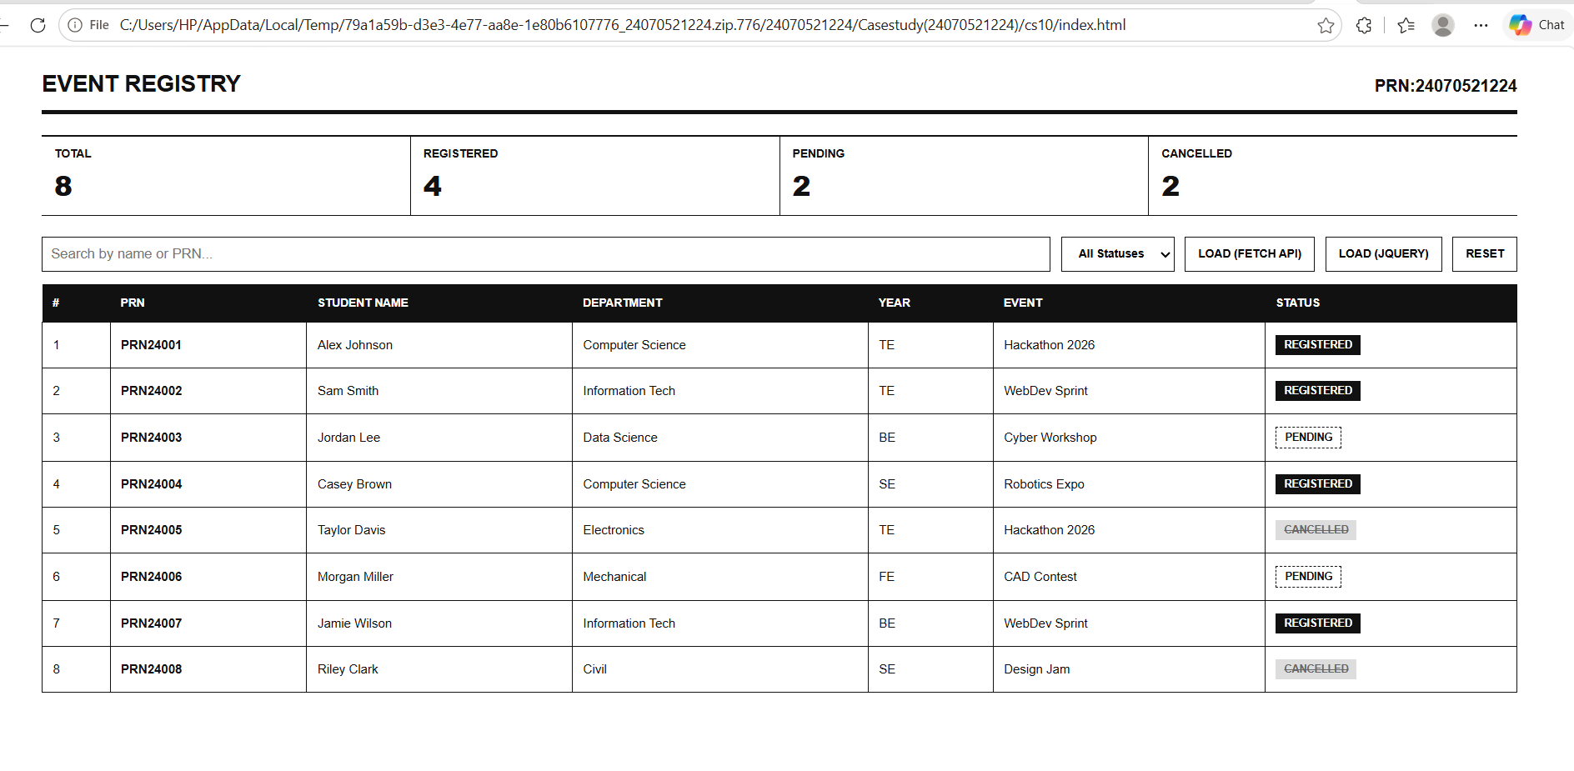

Conclusion
The Campus Event Registration System was successfully implemented using JSON, JavaScript Fetch API, and jQuery. Student data can be loaded, displayed, searched, and filtered efficiently.

